SPAGHETTI WITH ANCHOVY AND TOMATO SAUCE  COOK TIME: 15 mins  SOURCE: Unknown  #pasta #Italian #sauté | 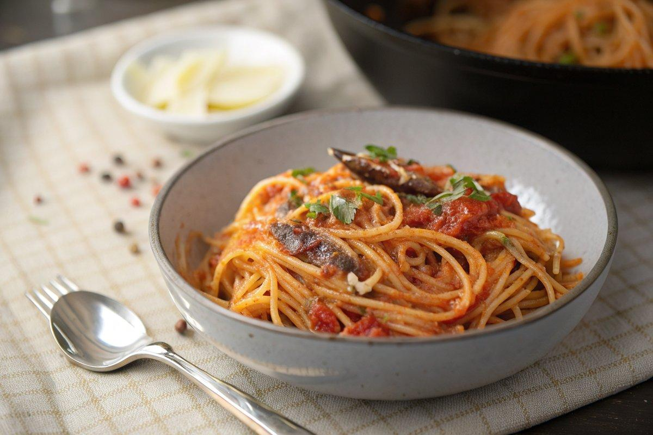

INGREDIENTS  - {'group': 'Main', 'item': '500g spaghetti'}  - {'group': 'Sauce', 'item': '3 tbsp olive oil'}  - {'group': 'Sauce', 'item': '5 anchovy fillets, drained and finely chopped'}  - {'group': 'Sauce', 'item': '2 garlic cloves, finely sliced'}  - {'group': 'Sauce', 'item': '1 tsp crushed chilli flakes or 1-2 tbsp pickled red jalapeño, diced'}  - {'group': 'Sauce', 'item': '400g can chopped tomatoes'}  - {'group': 'Sauce', 'item': '150g pitted black olives, roughly chopped'}  - {'group': 'Sauce', 'item': '2 tbsp small capers, rinsed and drained'}  - {'group': 'Garnish', 'item': '2-3 tbsp chopped fresh parsley (optional)'}  - {'group': 'Seasoning', 'item': 'Salt and pepper, to taste'} | PREP  Finely chop the anchovy fillets and slice the garlic cloves. Dice the pickled jalapeños if using.  COOK  Bring a large pot of salted water to a boil and cook the spaghetti according to package instructions. Meanwhile, heat olive oil in a frying pan over medium heat. Add the anchovies and cook, pressing with a wooden spoon, until they dissolve, about 3 mins. Stir in the garlic and chilli flakes or jalapeños, cooking for another minute. Add the chopped tomatoes, olives, and capers, and simmer for about 10 mins until the sauce thickens.  PLATING  Drain the spaghetti, reserving a cup of pasta water. Toss the spaghetti with the sauce in the pan, adding reserved water as needed to combine. Serve with chopped parsley, if desired.

NOTES:
Adjust the level of heat by varying the amount of chilli flakes or jalapeños. This dish pairs well with a simple green salad or garlic bread.

