SPICY CHICKEN STIR-FRY  COOK TIME: 20 mins  SOURCE: Unknown  #chicken #asian #stir-fry | 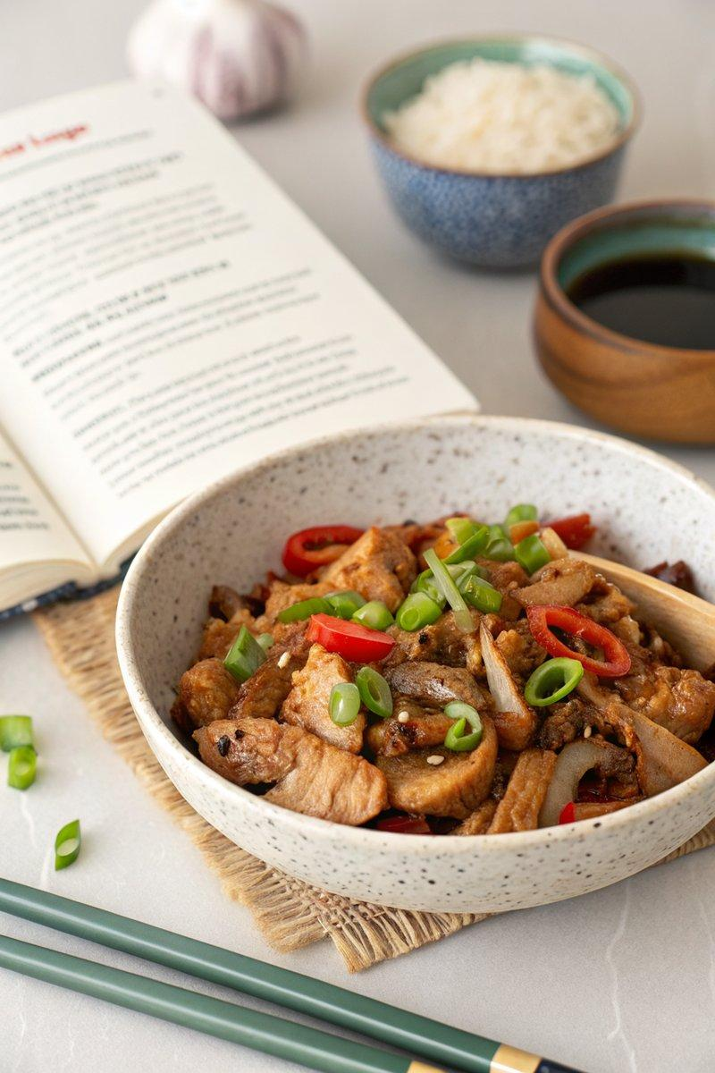

INGREDIENTS  - {'group': 'Main', 'item': '500g chicken breast, sliced'}  - {'group': 'Sauce', 'item': '3 tbsp soy sauce'}  - {'group': 'Sauce', 'item': '1 tbsp oyster sauce'}  - {'group': 'Seasoning', 'item': '2 cloves garlic, minced'}  - {'group': 'Seasoning', 'item': '1 tbsp fresh ginger, grated'}  - {'group': 'Seasoning', 'item': '1 red chili, sliced'}  - {'group': 'Garnish', 'item': '2 tbsp green onions, chopped'} | PREP  Slice the chicken breast into thin strips. Mince the garlic and grate the ginger. Slice the red chili and chop the green onions for garnish.  COOK  Heat a wok over high heat and add a splash of oil. Add the chicken strips and stir-fry until they are golden brown, about 5 mins. Add the minced garlic, grated ginger, and sliced chili, and stir-fry for another 2 mins until fragrant. Pour in the soy sauce and oyster sauce, stirring to coat the chicken evenly. Cook for an additional 3 mins until the sauce thickens slightly.  PLATING  Transfer the stir-fried chicken to a serving dish and sprinkle with chopped green onions. Serve immediately with steamed rice or stir-fried vegetables.

NOTES:
Adjust the amount of chili to your preferred spice level. For a gluten-free version, use tamari instead of soy sauce.

