CRISPY FRIED FISH TACOS WITH CREMA AND SLAW  COOK TIME: 5 mins  SOURCE: Unknown  #fish #Mexican #fried | 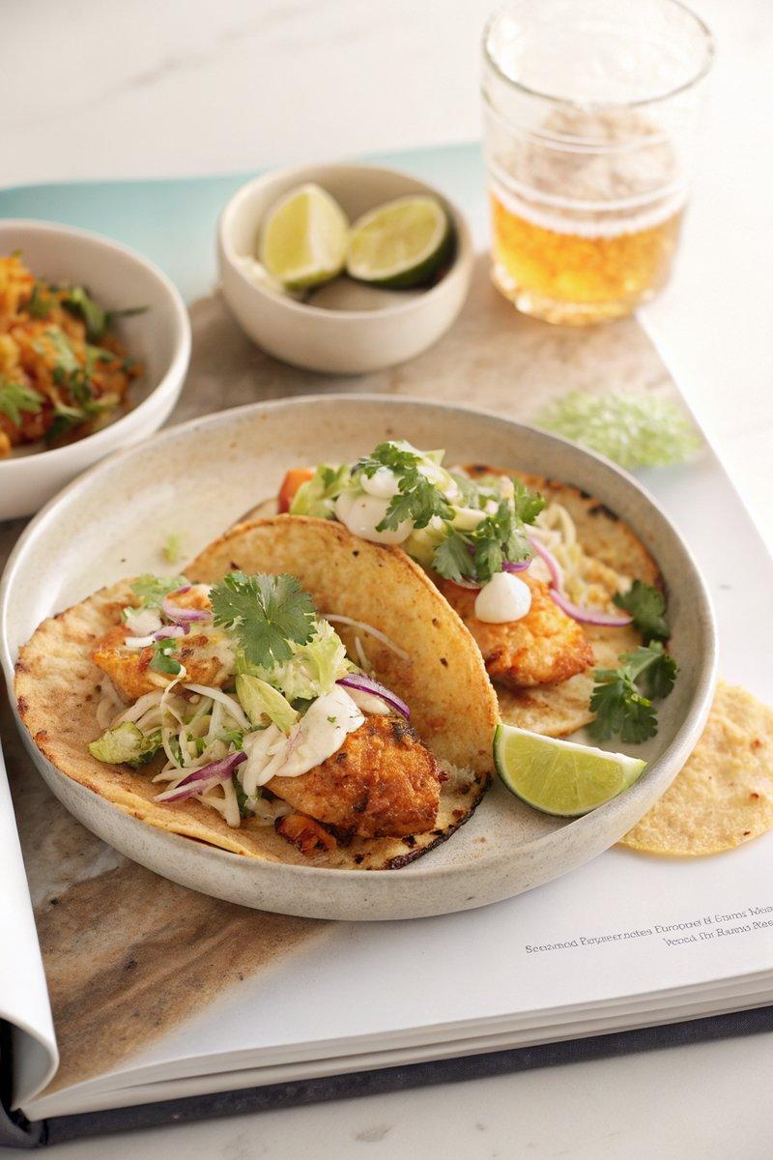

INGREDIENTS  - {'group': 'Main', 'item': '1 batch beer-battered fish'}  - {'group': 'Main', 'item': '16 corn tortillas'}  - {'group': 'Crema', 'item': '120g sour cream'}  - {'group': 'Crema', 'item': '115g mayonnaise'}  - {'group': 'Crema', 'item': '15ml hot sauce'}  - {'group': 'Crema', 'item': '5g smoked paprika'}  - {'group': 'Crema', 'item': '20ml Chinese black rice vinegar'}  - {'group': 'Crema', 'item': '2 cloves garlic, grated'}  - {'group': 'Slaw', 'item': '1 head green cabbage, very thinly sliced'}  - {'group': 'Slaw', 'item': '1 large red onion, thinly sliced'}  - {'group': 'Slaw', 'item': '8g finely chopped cilantro'}  - {'group': 'Slaw', 'item': 'Zest and juice of 2 lemons'}  - {'group': 'Slaw', 'item': '30ml extra-virgin olive oil'}  - {'group': 'Garnish', 'item': 'Cilantro leaves'}  - {'group': 'Garnish', 'item': 'Pickled jalapeños'}  - {'group': 'Garnish', 'item': 'Lime slices'} | PREP  In a small bowl, whisk together sour cream, mayonnaise, hot sauce, smoked paprika, vinegar, and garlic to make the crema. Season with salt and set aside. In a medium bowl, combine cabbage, onion, and cilantro for the slaw. Add lemon zest and juice, olive oil, salt, and pepper, then toss to mix thoroughly. Let the slaw sit for at least 5 minutes.  COOK  Heat a skillet over medium-high heat. Lightly char each tortilla for 20-25 seconds per side. Adjust heat if they char too quickly. Keep warm.  PLATING  To assemble, stack two tortillas per taco. Place a portion of beer-battered fish on each, followed by slaw and a drizzle of crema. Garnish with cilantro leaves, pickled jalapeños, and a squeeze of lime juice. Fold and serve immediately.

NOTES:
For a spicier kick, increase the amount of hot sauce in the crema. Serve with additional lime wedges for extra zest.

