AVOCADO AND EGG TOAST WITH CHILI OIL  COOK TIME: 2 mins  SOURCE: Unknown  #avocado #American #toast | 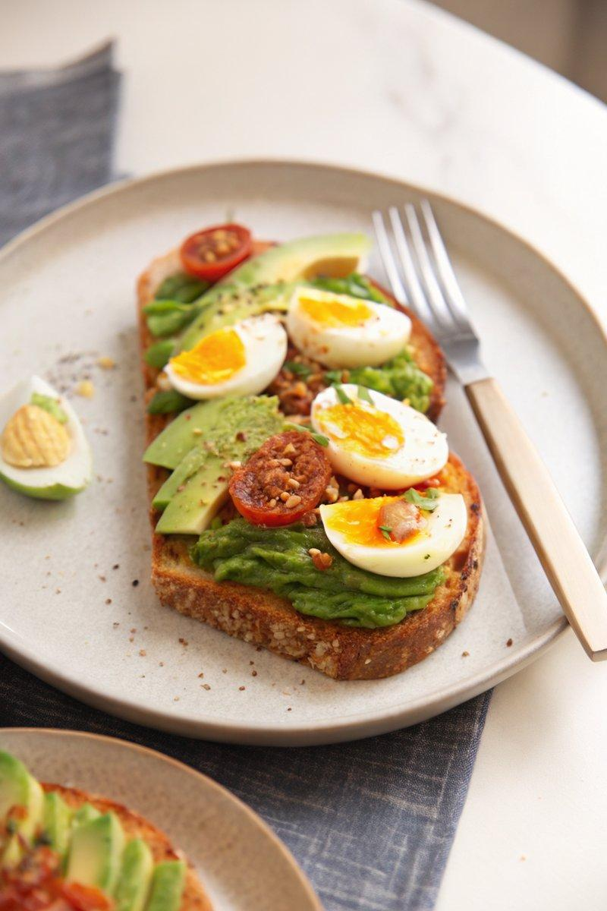

INGREDIENTS  - {'group': 'Main', 'item': '4 slices sourdough bread'}  - {'group': 'Main', 'item': '1 large avocado'}  - {'group': 'Main', 'item': '1 very ripe tomato'}  - {'group': 'Main', 'item': '1 clove garlic'}  - {'group': 'Main', 'item': '4 soft-boiled eggs, quartered'}  - {'group': 'Garnish', 'item': 'Schuan chili oil or spicy chili crisp, for drizzling'}  - {'group': 'Garnish', 'item': 'Flaky sea salt'}  - {'group': 'Garnish', 'item': 'Torn Thai basil or regular basil'} | PREP  Cut the garlic clove in half. Halve the tomato. Slice the avocado thinly. Prepare the soft-boiled eggs by quartering them.  COOK  Toast the sourdough bread slices until golden. Rub the cut sides of the garlic clove over the warm toast, followed by the tomato halves to infuse flavour.  PLATING  Arrange the avocado slices on the toast in a shingled pattern. Place the quartered eggs on top, drizzle with chili oil, and sprinkle with flaky sea salt and torn basil before serving.

NOTES:
For a spicier kick, add more chili oil. Use fresh basil for a fragrant finish.

