WHIPPED RICOTTA AND ROASTED GARLIC DIP  COOK TIME: 1 hour  SOURCE: Unknown  #ricotta #Mediterranean #dip | 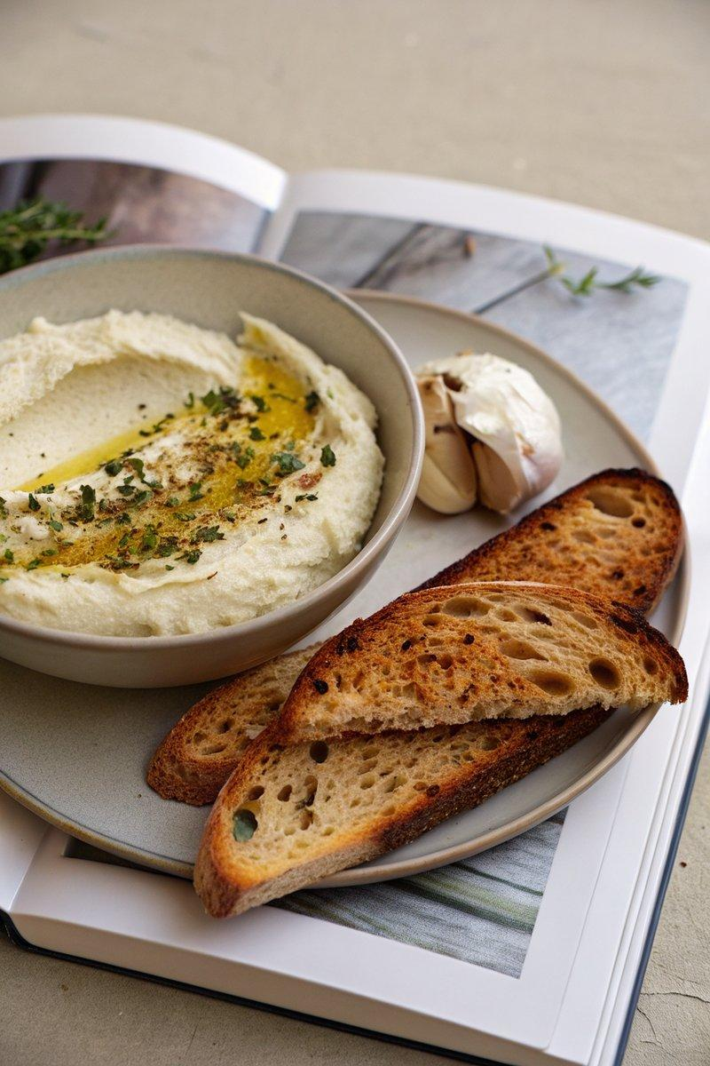

INGREDIENTS  - {'group': 'Main', 'item': '2 heads garlic'}  - {'group': 'Main', 'item': '3 tbsp neutral-tasting oil'}  - {'group': 'Main', 'item': '4 sprigs thyme'}  - {'group': 'Main', 'item': '1 cup (220g) ricotta'}  - {'group': 'Main', 'item': '1/4 cup (175ml) heavy whipping cream'}  - {'group': 'Main', 'item': 'Zest of 1 lemon'}  - {'group': 'Seasoning', 'item': 'Flaky sea salt, to taste'}  - {'group': 'Garnish', 'item': '1/2 cup (42g) finely crushed toasted pistachios'}  - {'group': 'Garnish', 'item': 'Extra-virgin olive oil for drizzling'}  - {'group': 'Garnish', 'item': 'Freshly cracked black pepper, to taste'}  - {'group': 'For Serving', 'item': 'Crackers, toasted baguette, or toasted sourdough bread'} | PREP  Preheat the oven to 170°C (340°F (171°C)). Trim the tops off the garlic heads to expose the cloves, keeping the bulbs intact. Remove any loose skin.  COOK  Place each garlic bulb on a piece of foil, drizzle with neutral oil, and add 2 thyme sprigs per bulb. Wrap tightly and bake for 1 hour until the garlic is soft and caramelized. Let cool, then squeeze the garlic cloves into a bowl and mash until smooth.  PLATING  In a medium bowl, whip the ricotta with a handheld mixer until smooth and airy. Incorporate the heavy cream, then fold in the garlic paste and lemon zest. Season with flaky sea salt. Transfer to a serving bowl, top with pistachios, a drizzle of olive oil, thyme leaves, and cracked pepper. Serve with your choice of crackers or toasted bread.

NOTES:
This dip can be prepared ahead of time and stored in the refrigerator, but is best served fresh for optimal texture and flavour.

