BROWNED BUTTER CORNBREAD  COOK TIME: 35 mins  SOURCE: Unknown  #cornbread #American #bake | 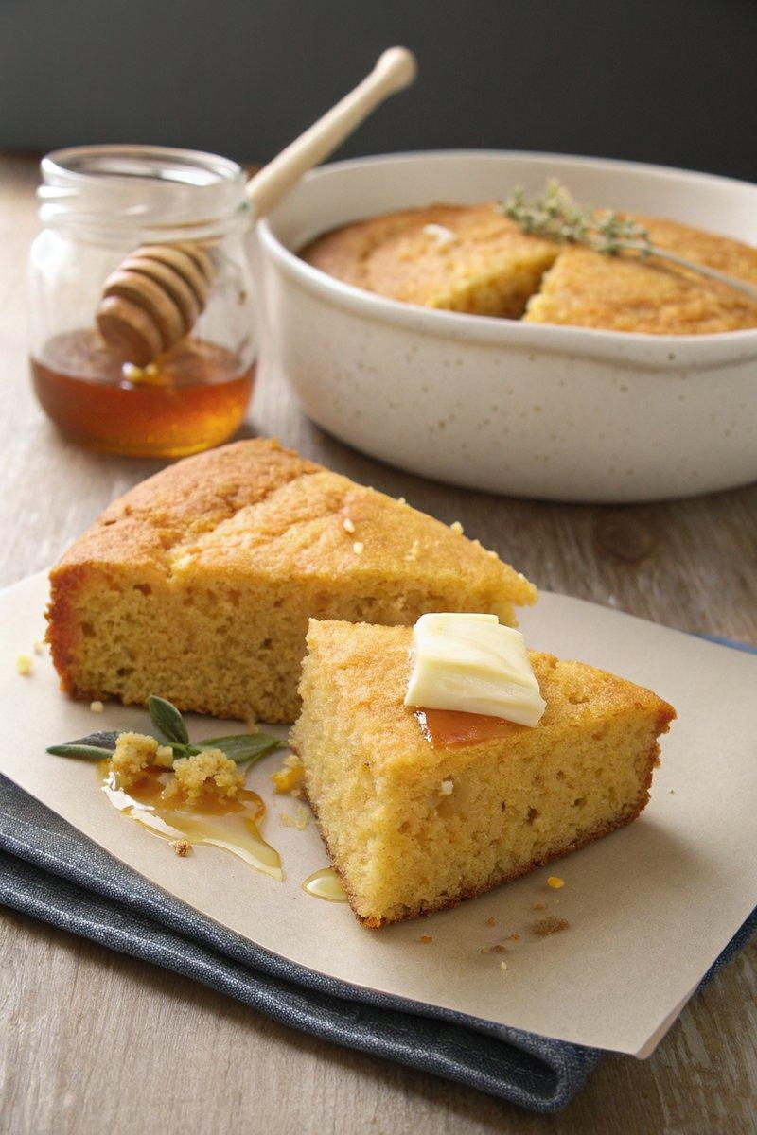

INGREDIENTS  - {'group': 'Main', 'item': '112g unsalted butter'}  - {'group': 'Main', 'item': '½ bunch sage'}  - {'group': 'Main', 'item': '½ bunch thyme'}  - {'group': 'Main', 'item': '188g unbleached all-purpose flour'}  - {'group': 'Main', 'item': '67g granulated sugar'}  - {'group': 'Main', 'item': '47g light brown sugar'}  - {'group': 'Main', 'item': '8g fine sea salt'}  - {'group': 'Main', 'item': '13g baking powder'}  - {'group': 'Main', 'item': '175g finely ground yellow cornmeal'}  - {'group': 'Main', 'item': '2 large eggs'}  - {'group': 'Main', 'item': '350ml buttermilk'} | PREP  Preheat the oven to 200°C (400°F (200°C)) with an 8-inch (20cm (8-inch)) cast-iron skillet inside. Melt the butter in a small pot over medium heat, allowing it to brown until it turns dark brown. Add sage and thyme, then transfer to a container to cool slightly.  COOK  In a bowl, whisk together flour, granulated sugar, brown sugar, salt, baking powder, and cornmeal. In another bowl, whisk the eggs and buttermilk. Remove herbs from the cooled butter, then slowly whisk the butter into the buttermilk mixture. Combine this with the dry ingredients until smooth. Carefully remove the hot skillet from the oven, lightly grease it, and pour in the batter, spreading it evenly. Bake for 20-25 minutes until a toothpick inserted in the center comes out clean.  PLATING  Allow the cornbread to cool in the skillet for a few minutes before transferring to a cooling rack. Once cooled, cut into 8 wedges and serve.

NOTES:
No additional notes

