CREAMY CHICKEN À LA KING  COOK TIME: 20 mins  SOURCE: Unknown  #chicken #American #sauté | 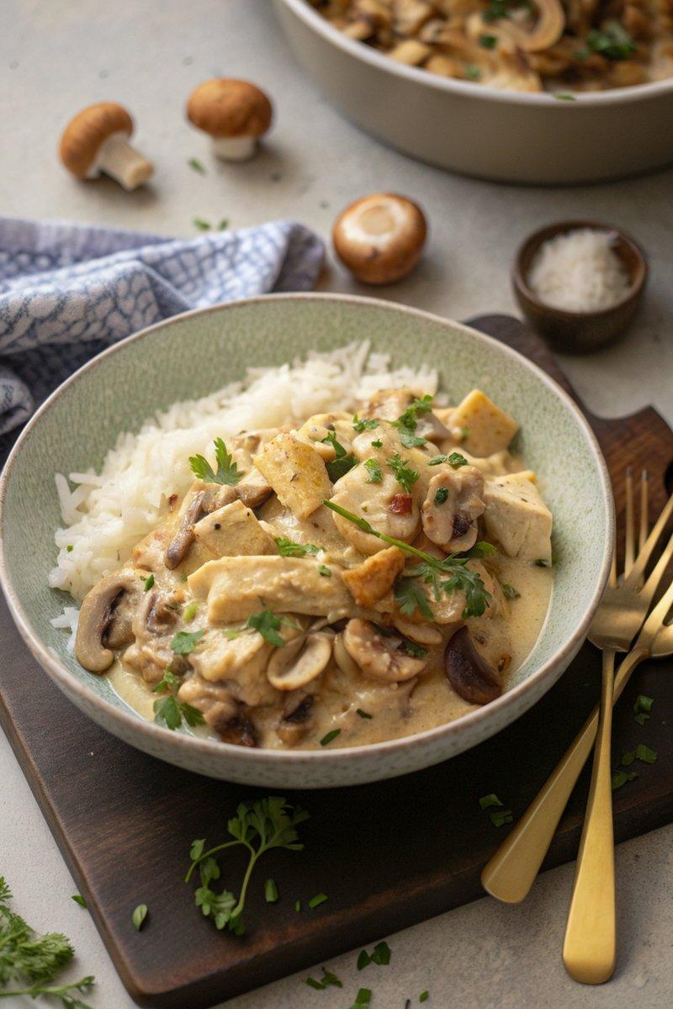

INGREDIENTS  - {'group': 'Main', 'item': '2 large cooked chicken breasts, shredded or chopped (about 250g)'}  - {'group': 'Main', 'item': '12 baby chestnut mushrooms, halved'}  - {'group': 'Main', 'item': '1 large onion, sliced'}  - {'group': 'Sauce', 'item': '2 tbsp plain flour'}  - {'group': 'Sauce', 'item': '280ml hot chicken stock'}  - {'group': 'Sauce', 'item': '200ml milk'}  - {'group': 'Sauce', 'item': '1/2 tsp dried thyme or 1 tsp fresh thyme leaves'}  - {'group': 'Sauce', 'item': '2 tbsp dry sherry'}  - {'group': 'Seasoning', 'item': '1/4 tsp salt'}  - {'group': 'Seasoning', 'item': '1/4 tsp ground black pepper'}  - {'group': 'Garnish', 'item': 'Chopped flat-leaf parsley'}  - {'group': 'For Serving', 'item': 'Cooked rice or pasta'} | PREP  Slice the mushrooms in half and the onion into thin slices. Shred or chop the cooked chicken breasts into bite-sized pieces.  COOK  Heat 1 tbsp of olive oil in a large frying pan over medium-high heat. Add the mushrooms and cook until golden brown, about 3-4 mins, then set aside. In the same pan, add the remaining oil and sauté the onion for 5-6 mins until slightly browned. Stir in the flour and cook for 1 min. Gradually whisk in the hot chicken stock, ensuring no lumps form. Once smooth, add the milk and thyme, stirring until the sauce thickens. Incorporate the sherry, salt, and pepper, adjusting seasoning as needed. Return the mushrooms and add the chicken, cooking for 2-3 mins until heated through.  PLATING  Serve the chicken mixture over a bed of fluffy rice or pasta, garnished with chopped parsley.

NOTES:
This dish is perfect for using leftover chicken. Adjust the seasoning to taste, and consider using rotisserie chicken for convenience.

