SLOW-COOKED CHICKEN AND VEGETABLE SOUP  COOK TIME: 6 hrs  SOURCE: Unknown  #chicken #American #slow-cook | 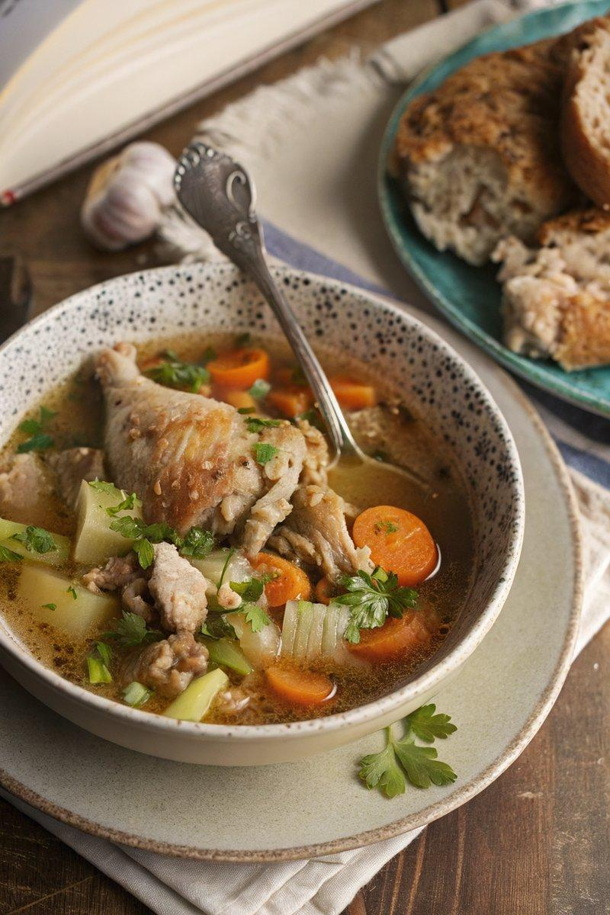

INGREDIENTS  - {'group': 'Main', 'item': '4 bone-in, skin-on chicken thighs'}  - {'group': 'Main', 'item': '4 chicken drumsticks'}  - {'group': 'Main', 'item': '1 onion, peeled and finely chopped'}  - {'group': 'Main', 'item': '2 garlic cloves, peeled and minced'}  - {'group': 'Main', 'item': '2 celery sticks, sliced'}  - {'group': 'Main', 'item': '3 medium carrots, roughly chopped'}  - {'group': 'Main', 'item': '2 medium potatoes, peeled and chopped into bite-size chunks'}  - {'group': 'Main', 'item': '1 bay leaf'}  - {'group': 'Seasoning', 'item': '¼ tsp salt'}  - {'group': 'Seasoning', 'item': '½ tsp ground black pepper'}  - {'group': 'Main', 'item': '1 L strong chicken stock'}  - {'group': 'Garnish', 'item': 'Chopped flat-leaf parsley or thyme'} | PREP  Peel and finely chop the onion. Mince the garlic cloves. Slice the celery sticks and roughly chop the carrots. Peel and chop the potatoes into bite-size chunks.  COOK  Place the chicken thighs, drumsticks, onion, garlic, celery, carrots, potatoes, bay leaf, salt, pepper, and chicken stock into the slow cooker. Cover with the lid and cook on low for 6 hours or on high for 4 hours. Once cooked, remove the chicken pieces and bay leaf. Discard the bay leaf and shred the chicken meat using two forks, discarding the skin.  PLATING  Return the shredded chicken to the slow cooker and stir to combine. Serve the soup in bowls, garnished with fresh parsley or thyme, alongside crusty bread.

NOTES:
This soup can be made ahead and stored in the refrigerator. Reheat in a pan until piping hot before serving.

