CORNISH BEEF AND VEGETABLE PASTIES  COOK TIME: 50 mins  SOURCE: Unknown  #beef #British #baked | 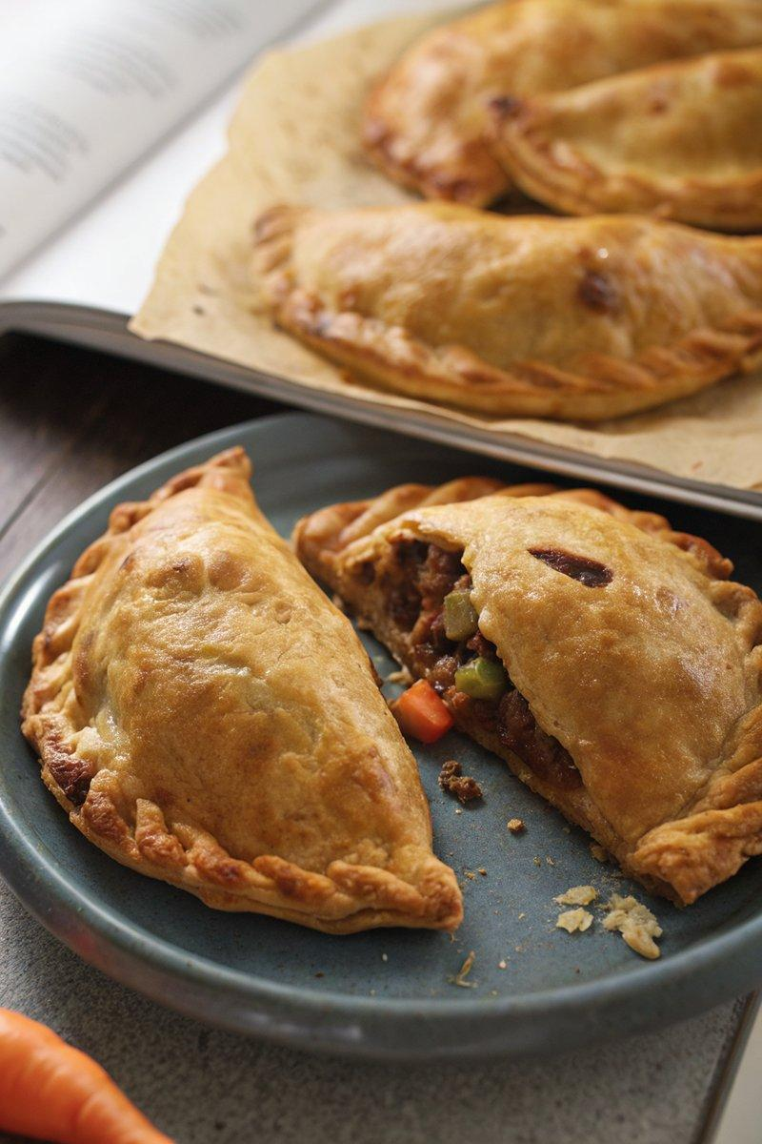

INGREDIENTS  - {'group': 'Pastry', 'item': '450g plain flour, plus extra for rolling'}  - {'group': 'Pastry', 'item': '2 tsp baking powder'}  - {'group': 'Pastry', 'item': '1 tsp salt'}  - {'group': 'Pastry', 'item': '125g unsalted butter, chopped'}  - {'group': 'Pastry', 'item': '2 egg yolks'}  - {'group': 'Pastry', 'item': '125ml cold water'}  - {'group': 'Filling', 'item': '450g potatoes, peeled and finely diced'}  - {'group': 'Filling', 'item': '150g swede, peeled and finely diced'}  - {'group': 'Filling', 'item': '150g onion, finely chopped'}  - {'group': 'Filling', 'item': '300g skirt steak, finely chopped'}  - {'group': 'Filling', 'item': '1 tsp salt'}  - {'group': 'Filling', 'item': '1 tsp ground black pepper'}  - {'group': 'Filling', 'item': '45g unsalted butter, chopped into small cubes'}  - {'group': 'Glaze', 'item': '1 egg, beaten'} | PREP  In a food processor, combine flour, baking powder, and salt. Add butter and pulse until mixture resembles breadcrumbs. Mix in egg yolks, then gradually add water until dough forms. Wrap in cling film and refrigerate for 1 hour. Meanwhile, prepare the filling by finely dicing potatoes, swede, and onion, and chopping the steak.  COOK  Preheat oven to 180°C (350°F (175°C)). Roll out chilled pastry to 3mm thickness on a floured surface. Cut into 20cm (8-inch) circles. Mix potatoes, swede, onion, steak, salt, and pepper in a bowl. Place filling on half of each pastry circle, leaving a border. Dot with butter cubes. Brush edges with egg wash, fold over, and crimp to seal. Place on baking tray, cut a steam vent, and brush with egg wash. Bake for 50 mins until golden brown.  PLATING  Allow pasties to cool for 5 mins before serving. Serve warm with a side of green salad or pickles.

NOTES:
For convenience, you can use store-bought shortcrust pastry. Refrigerate cooked pasties and reheat in a 190°C (375°F (190°C)) oven for 30 mins until hot.

