CREAMY FISH AND PRAWN PIE WITH CHEESY MASH  COOK TIME: 35 mins  SOURCE: Unknown  #fish #British #bake | 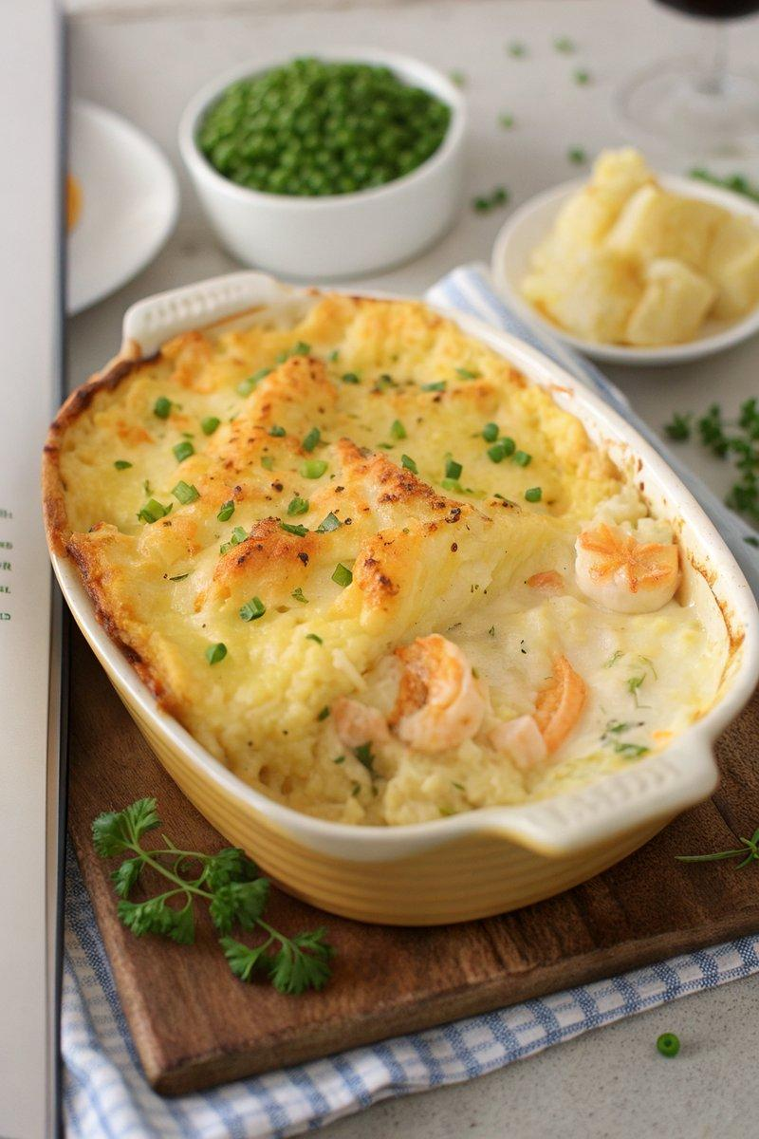

INGREDIENTS  - {'group': 'Main', 'item': '1 kg floury potatoes, peeled and chopped'}  - {'group': 'Main', 'item': '3 tbsp unsalted butter'}  - {'group': 'Main', 'item': '3 tbsp double cream'}  - {'group': 'Main', 'item': 'large pinch of salt and pepper'}  - {'group': 'Main', 'item': '600 ml milk'}  - {'group': 'Main', 'item': '2 salmon fillets'}  - {'group': 'Main', 'item': '2 cod or haddock fillets'}  - {'group': 'Main', 'item': '12-18 king prawns, deveined'}  - {'group': 'Sauce', 'item': '2 tbsp plain flour'}  - {'group': 'Sauce', 'item': '150 g grated mature Cheddar'}  - {'group': 'Garnish', 'item': '1 tbsp chopped chives'} | PREP  Peel and chop the potatoes into large chunks. Grate the Cheddar cheese and chop the chives. If using raw prawns, ensure they are deveined.  COOK  Preheat the oven to 200°C (400°F (200°C)). Boil the potatoes in a pan of water for 15 mins, then drain and mash with half the butter, cream, salt, and pepper. In a large saucepan, bring the milk to a boil with the salmon and cod, simmering for 3 mins. Add raw prawns in the last minute if using. Transfer the fish and prawns to a baking dish, discarding any skin. Reserve the cooking liquid. Melt the remaining butter in a saucepan, stir in the flour, and cook for 1 min. Gradually add the reserved liquid, stirring until thickened. Remove from heat and mix in half the cheese and a pinch of pepper.  PLATING  Pour the sauce over the fish and prawns in the baking dish. Spread the mashed potatoes on top, roughing up the surface with a fork. Sprinkle with remaining cheese and bake for 15-20 mins until golden. Garnish with chives before serving.

NOTES:
This dish can be prepared ahead and refrigerated or frozen before baking. If reheating from the fridge, bake at 200°C (400°F (200°C)) for 30-35 mins, covering for the first half of the time.

