SLOW-COOKED BEEF AND POTATO PIE  COOK TIME: 2 hrs 35 mins  SOURCE: Unknown  #beef #British #bake | 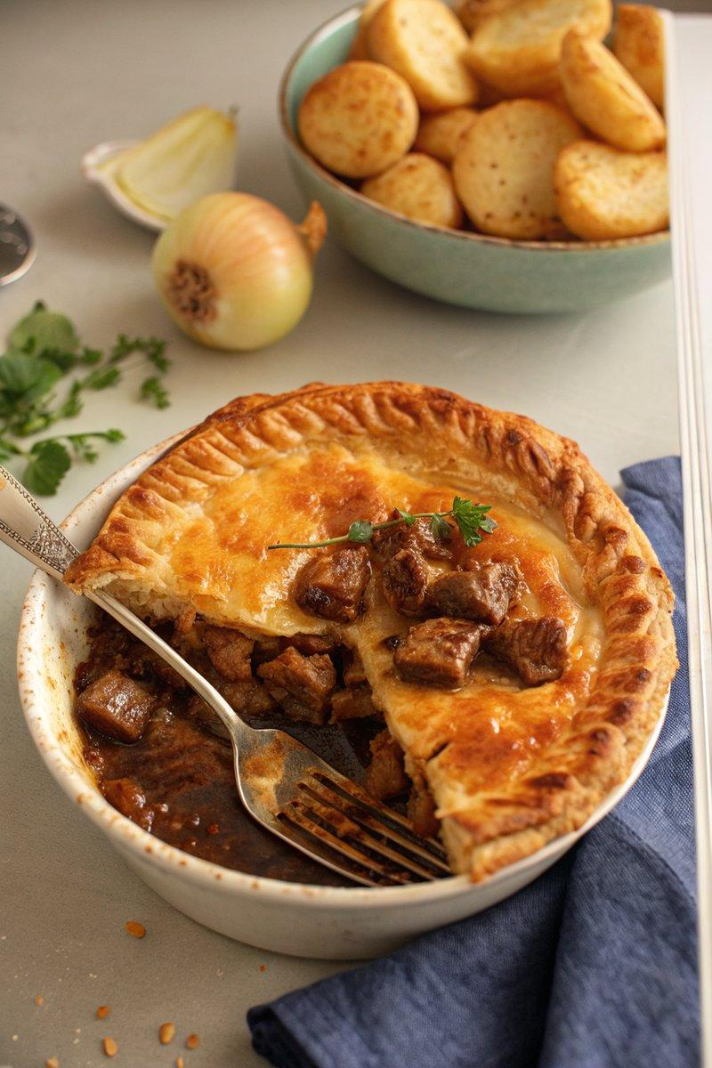

INGREDIENTS  - {'group': 'Main', 'item': '500g braising beef, chopped into bite-size chunks'}  - {'group': 'Main', 'item': '1 large onion, peeled and chopped'}  - {'group': 'Main', 'item': '2 large potatoes, peeled and chopped'}  - {'group': 'Main', 'item': '1 tbsp sunflower oil'}  - {'group': 'Seasoning', 'item': '1 tbsp plain flour'}  - {'group': 'Seasoning', 'item': '1 tsp salt'}  - {'group': 'Seasoning', 'item': '1 tsp ground black pepper'}  - {'group': 'Sauce', 'item': '600ml hot beef stock'}  - {'group': 'Sauce', 'item': '1 tsp Worcestershire sauce'}  - {'group': 'Pastry', 'item': '2x 320g packs of ready-rolled shortcrust pastry'}  - {'group': 'Pastry', 'item': '1 egg, lightly whisked'} | PREP  Preheat the oven to 150°C (300°F (150°C)). Chop the onion and potatoes. Cut the beef into bite-size chunks and toss with flour, salt, and pepper.  COOK  Heat oil in a casserole dish over medium-low heat, sauté the onion for 5 mins. Add beef and cook until browned, about 5 mins. Pour in beef stock, half the potatoes, Worcestershire sauce, and remaining seasoning. Bring to a boil, cover, and bake for 1 hr. Stir, add remaining potatoes, and bake for another hour. Increase oven to 200°C (400°F (200°C)).  PLATING  Line a 25cm pie dish with one pastry sheet, fill with beef mixture, and cover with the second pastry sheet. Crimp edges, brush with egg wash, and pierce to vent steam. Bake for 30-35 mins until golden. Serve with steamed vegetables.

NOTES:
For extra gravy, add 500ml more stock when cooking the filling. Use a slotted spoon to transfer filling to the pie dish, reserving the liquid as gravy.

