SLOW-COOKED BEEF MASSAMAN CURRY  COOK TIME: 2 hrs 15 mins  SOURCE: Unknown  #beef #Asian #slow-cook | 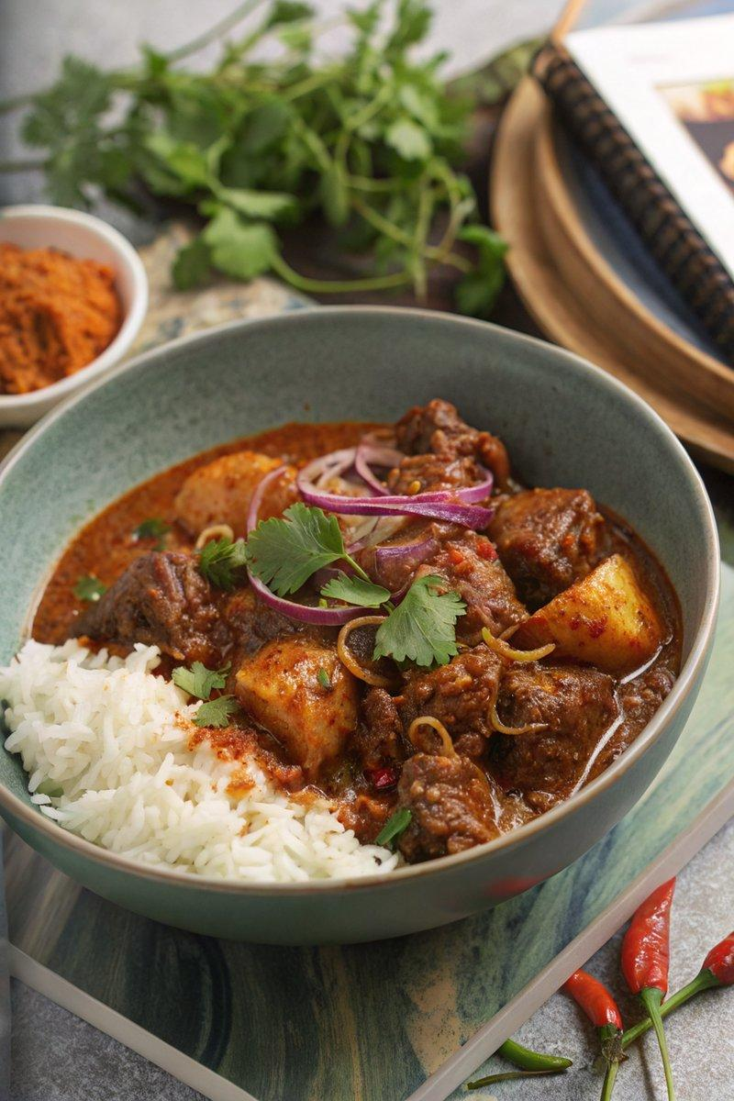

INGREDIENTS  - {'group': 'Massaman Paste', 'item': '1 red onion, peeled and chopped'}  - {'group': 'Massaman Paste', 'item': '1-3 mild red chillies, chopped'}  - {'group': 'Massaman Paste', 'item': '2 tsp ground coriander'}  - {'group': 'Massaman Paste', 'item': '2 tsp ground cumin'}  - {'group': 'Massaman Paste', 'item': '1/2 tsp ground cinnamon'}  - {'group': 'Massaman Paste', 'item': '1/2 tsp white pepper'}  - {'group': 'Massaman Paste', 'item': '3 garlic cloves, peeled'}  - {'group': 'Massaman Paste', 'item': '2 tsp lemongrass paste'}  - {'group': 'Massaman Paste', 'item': '1 tsp minced ginger'}  - {'group': 'Massaman Paste', 'item': '1 tsp shrimp paste'}  - {'group': 'Massaman Paste', 'item': '3 tsp fish sauce'}  - {'group': 'Massaman Paste', 'item': '1 tsp brown sugar'}  - {'group': 'Massaman Paste', 'item': 'Small bunch of fresh coriander stalks'}  - {'group': 'Massaman Paste', 'item': '1/2 tsp salt'}  - {'group': 'Main', 'item': '1.5 tbsp cornflour'}  - {'group': 'Main', 'item': '1/4 tsp salt'}  - {'group': 'Main', 'item': '1/4 tsp ground black pepper'}  - {'group': 'Main', 'item': '1kg braising beef (beef chuck), chopped into chunks'}  - {'group': 'Main', 'item': '2 tbsp sunflower oil'}  - {'group': 'Main', 'item': '400ml beef stock'}  - {'group': 'Main', 'item': '400g can coconut milk'}  - {'group': 'Main', 'item': '500g baby new potatoes'}  - {'group': 'Main', 'item': 'Juice of 1 lime'}  - {'group': 'For Serving', 'item': 'Cooked rice'}  - {'group': 'For Serving', 'item': 'Sliced red chillies'}  - {'group': 'For Serving', 'item': 'Sliced spring onions'}  - {'group': 'For Serving', 'item': 'Fresh coriander leaves'}  - {'group': 'For Serving', 'item': 'Lime wedges'} | PREP  In a blender, combine the red onion, chillies, ground coriander, cumin, cinnamon, white pepper, garlic, lemongrass paste, ginger, shrimp paste, fish sauce, brown sugar, fresh coriander stalks, and salt. Blend until a smooth paste forms. Set aside.  COOK  In a bowl, mix cornflour, salt, and black pepper. Coat the beef chunks in this mixture. Heat sunflower oil in a large pan over medium-high heat. Sear the beef in batches until browned, about 5 mins per batch. Reduce heat to medium, add the massaman paste, and stir to coat the beef. Cook for 2 mins. Pour in the beef stock and coconut milk, scraping up any browned bits from the pan. Bring to a boil, then reduce to a simmer, cover, and cook for 1 hr 45 mins. Stir occasionally, adding more stock if it becomes too dry. Add the baby potatoes and continue to simmer for another 30 mins until tender.  PLATING  Stir in the lime juice before serving. Serve the curry over a bed of cooked rice, garnished with sliced red chillies, spring onions, fresh coriander leaves, and lime wedges.

NOTES:
This curry can be made ahead and stored in the refrigerator for up to 2 days or frozen for later use. Reheat thoroughly before serving, adding a splash of water or stock if needed.

