CREAMY CHICKEN KORMA  COOK TIME: 20 mins  SOURCE: Unknown  #chicken #Indian #sauté | 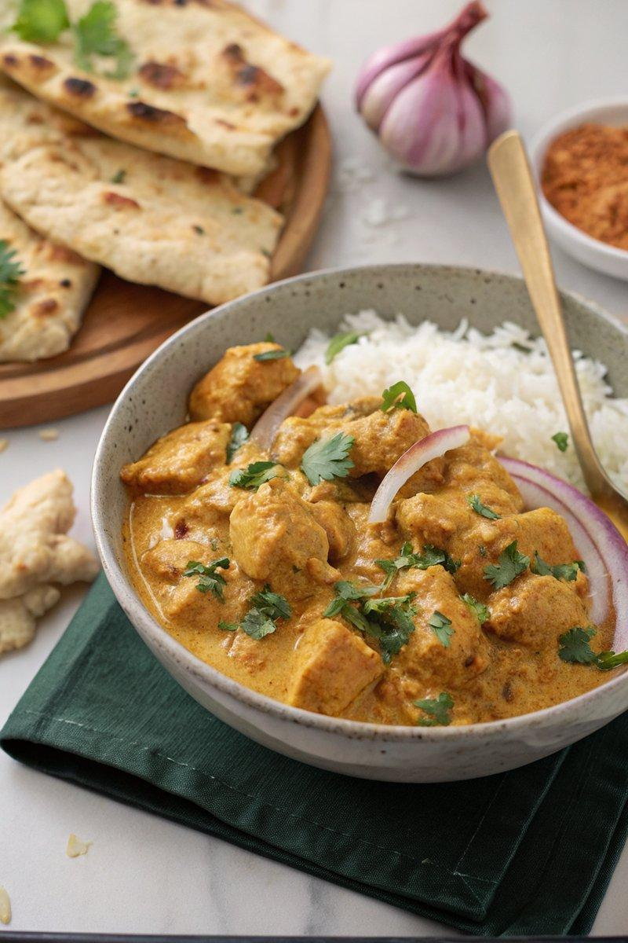

INGREDIENTS  - {'group': 'Main', 'item': '2 tbsp ghee or sunflower oil'}  - {'group': 'Main', 'item': '1 onion, finely chopped'}  - {'group': 'Main', 'item': '600g chicken breasts, chopped into bite-size chunks'}  - {'group': 'Main', 'item': '2 garlic cloves, minced'}  - {'group': 'Main', 'item': '2 tsp minced ginger'}  - {'group': 'Seasoning', 'item': '1 tsp ground cumin'}  - {'group': 'Seasoning', 'item': '1½ tsp ground coriander'}  - {'group': 'Seasoning', 'item': '1½ tsp garam masala'}  - {'group': 'Seasoning', 'item': '½ tsp mild chili powder (optional)'}  - {'group': 'Seasoning', 'item': '½ tsp turmeric'}  - {'group': 'Seasoning', 'item': '¼ tsp salt'}  - {'group': 'Seasoning', 'item': '¼ tsp white pepper'}  - {'group': 'Sauce', 'item': '2 tbsp tomato purée'}  - {'group': 'Sauce', 'item': '120 ml natural yogurt'}  - {'group': 'Sauce', 'item': '120 ml coconut cream'}  - {'group': 'Sauce', 'item': '2 tbsp ground almonds'}  - {'group': 'Sauce', 'item': '1 tbsp sugar'}  - {'group': 'Sauce', 'item': '60 ml double cream'}  - {'group': 'For Serving', 'item': 'cooked rice'}  - {'group': 'For Serving', 'item': 'naan'}  - {'group': 'Garnish', 'item': 'freshly chopped coriander'} | PREP  Chop the onion finely and cut the chicken breasts into bite-size chunks. Mince the garlic and ginger.  COOK  Heat the ghee in a large frying pan over medium heat. Add the onion and sauté for about 5 minutes until softened. Add the chicken pieces and cook for another 5 minutes until sealed. Stir in the garlic, ginger, cumin, coriander, garam masala, chili powder, turmeric, salt, and white pepper. Cook for 2 minutes until fragrant. Mix in the tomato purée, yogurt, coconut cream, ground almonds, and sugar. Bring to a gentle boil, then reduce the heat and simmer for 6-8 minutes until the chicken is cooked through. Stir in the double cream and remove from heat.  PLATING  Serve the chicken korma hot, garnished with freshly chopped coriander. Accompany with cooked rice and naan.

NOTES:
Coconut cream is thicker than coconut milk and can be made by chilling coconut milk and using the solid portion. The korma can be made ahead and stored in the refrigerator for up to 2 days. Reheat gently, adding a little water or cream if needed.

