CHORIZO AND BEAN TORTILLA BAKE  COOK TIME: 20 mins  SOURCE: Unknown  #chorizo #Mexican #bake | 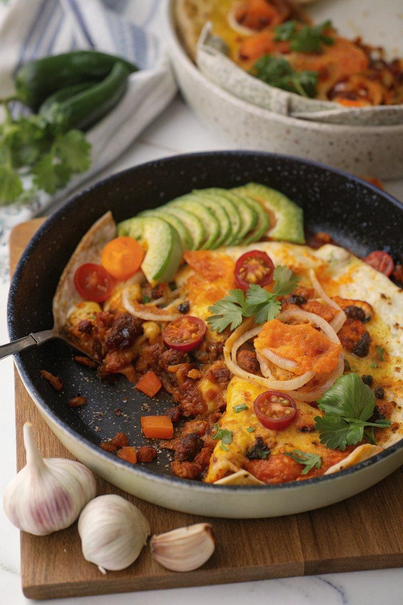

INGREDIENTS  - {'group': 'Chorizo Sauce', 'item': '1½ tbsp sunflower oil'}  - {'group': 'Chorizo Sauce', 'item': '1 onion, finely diced'}  - {'group': 'Chorizo Sauce', 'item': '1 carrot, finely diced'}  - {'group': 'Chorizo Sauce', 'item': '100g chorizo, chopped'}  - {'group': 'Chorizo Sauce', 'item': '2 garlic cloves, minced'}  - {'group': 'Chorizo Sauce', 'item': '1 red or yellow bell pepper, chopped'}  - {'group': 'Chorizo Sauce', 'item': '1 small courgette, chopped'}  - {'group': 'Chorizo Sauce', 'item': '1 tsp ground cumin'}  - {'group': 'Chorizo Sauce', 'item': '1 tsp ground coriander'}  - {'group': 'Chorizo Sauce', 'item': '½ tsp cinnamon'}  - {'group': 'Chorizo Sauce', 'item': '½ tsp chilli flakes'}  - {'group': 'Chorizo Sauce', 'item': '800g canned chopped tomatoes'}  - {'group': 'Chorizo Sauce', 'item': '400g canned mixed beans in chilli or tomato sauce'}  - {'group': 'Chorizo Sauce', 'item': '¼ tsp salt'}  - {'group': 'Chorizo Sauce', 'item': '¼ tsp ground black pepper'}  - {'group': 'Cheese Sauce', 'item': '50g grated Cheddar'}  - {'group': 'Cheese Sauce', 'item': '4 tbsp double cream'}  - {'group': 'Cheese Sauce', 'item': '3 tbsp sour cream'}  - {'group': 'Cheese Sauce', 'item': 'a pinch of salt and pepper'}  - {'group': 'Assembly', 'item': '2 large flour tortillas'}  - {'group': 'Assembly', 'item': '100g mixed Cheddar and Red Leicester cheese, grated'} | PREP  Finely dice the onion and carrot. Chop the chorizo, bell pepper, and courgette into small chunks. Mince the garlic.  COOK  Heat sunflower oil in a large oven-safe frying pan over medium heat. Sauté the onion and carrot for 5 mins until softened. Add chorizo and cook for 3-4 mins until it releases its oils. Stir in garlic, bell pepper, and courgette, cooking for 2 mins. Mix in cumin, coriander, cinnamon, and chilli flakes, cooking for 1 min. Add chopped tomatoes, mixed beans, salt, and pepper. Bring to a simmer and cook for 10 mins.  PLATING  Spread half the chorizo mixture in the pan, place a tortilla on top, and cover with half the cheese sauce. Add remaining chorizo mixture, top with the second tortilla, and spread the rest of the cheese sauce. Sprinkle with mixed cheese. Heat on stovetop until bubbling, then grill for 2-3 mins until cheese is melted. Garnish with fresh coriander, sliced chilli, avocado, and red onion before serving.

NOTES:
For a vegetarian version, replace chorizo with 200g canned chickpeas mixed with 1 tsp smoked paprika and use vegetarian cheese.

