QUICK CHICKEN RAMEN SOUP  COOK TIME: 13 mins  SOURCE: Unknown  #chicken #asian #soup | 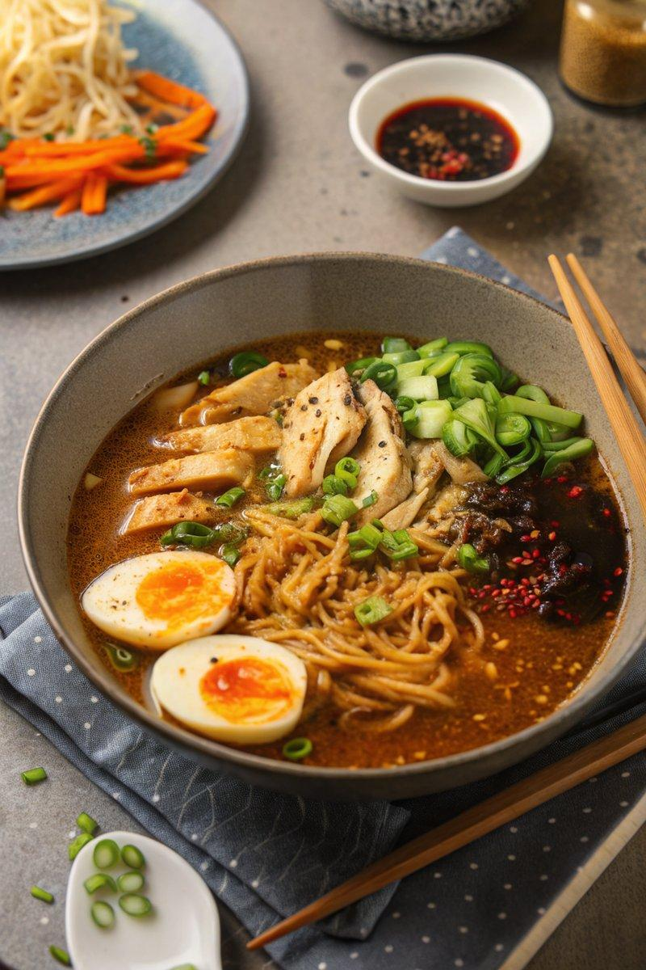

INGREDIENTS  - {'group': 'Main', 'item': '1 tsp sesame oil'}  - {'group': 'Main', 'item': '2 tbsp unsalted butter'}  - {'group': 'Main', 'item': '4 garlic cloves, minced'}  - {'group': 'Main', 'item': '2 tsp minced ginger'}  - {'group': 'Main', 'item': '1.4L chicken stock'}  - {'group': 'Sauce', 'item': '2 tbsp light soy sauce'}  - {'group': 'Sauce', 'item': '2 tbsp dark soy sauce'}  - {'group': 'Sauce', 'item': '1-2 tbsp sriracha hot sauce'}  - {'group': 'Sauce', 'item': '1 tbsp Chinese rice wine or sherry'}  - {'group': 'Sauce', 'item': '1 tbsp light brown sugar'}  - {'group': 'Seasoning', 'item': '1/4 tsp ground white pepper'}  - {'group': 'Main', 'item': '3 cooked chicken breasts, shredded'}  - {'group': 'Main', 'item': '210g instant noodles'}  - {'group': 'Toppings', 'item': '5 spring onions, chopped'}  - {'group': 'Toppings', 'item': '4 boiled eggs, halved'}  - {'group': 'Toppings', 'item': '1 carrot, julienned'}  - {'group': 'Toppings', 'item': '1 tsp black and white sesame seeds'}  - {'group': 'Toppings', 'item': '2 tsp chilli oil or chilli paste'} | PREP  Peel and mince the garlic and ginger. Shred the cooked chicken breasts. Chop the spring onions and julienne the carrot. Boil and halve the eggs.  COOK  In a large saucepan, heat sesame oil and butter over medium heat until the butter melts. Add garlic and ginger, sauté for 1 minute. Pour in chicken stock, light and dark soy sauces, sriracha, rice wine, brown sugar, and white pepper. Stir well, then add shredded chicken. Increase heat to high, bring to a boil, then simmer for 3 minutes. Add instant noodles, return to a boil, and simmer for another 3 minutes, stirring occasionally.  PLATING  Divide the noodles among four bowls using tongs. Ladle the broth and chicken over the noodles. Top each bowl with spring onions, two egg halves, and carrot. Sprinkle with sesame seeds and drizzle with chilli oil or paste before serving.

NOTES:
For jammy boiled eggs, simmer medium eggs for 6 minutes, then cool in ice water before peeling. The broth can be made ahead and stored for up to 2 days without the noodles and chicken.

