SALMON EN PAPILLOTE WITH VEGETABLES  COOK TIME: 18 mins  SOURCE: Unknown  #salmon #asian #bake | 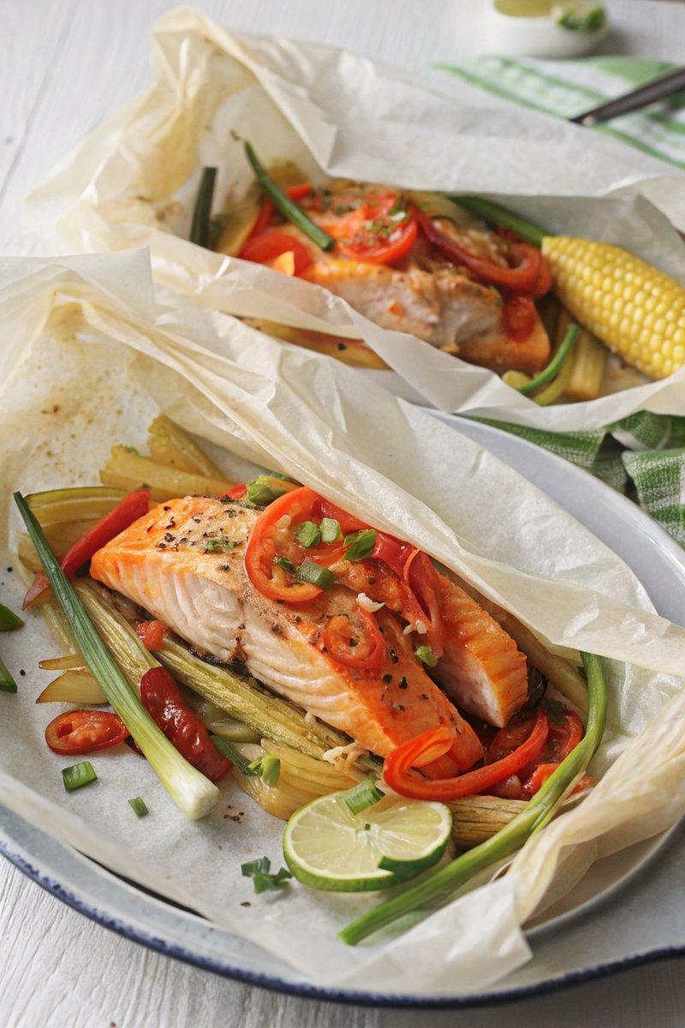

INGREDIENTS  - {'group': 'Main', 'item': '2 skin-on salmon fillets'}  - {'group': 'Main', 'item': '½ red bell pepper, deseeded and sliced'}  - {'group': 'Main', 'item': '100g fresh baby corn'}  - {'group': 'Main', 'item': '1 carrot, peeled and sliced into matchsticks'}  - {'group': 'Main', 'item': '1 red chilli, sliced'}  - {'group': 'Sauce', 'item': '2 tsp sunflower oil'}  - {'group': 'Sauce', 'item': '1 tsp sesame oil'}  - {'group': 'Sauce', 'item': '1 garlic clove, minced'}  - {'group': 'Sauce', 'item': '1½ tbsp light soy sauce'}  - {'group': 'Sauce', 'item': '1½ tbsp honey'}  - {'group': 'Garnish', 'item': '6 spring onions, sliced into thin strips'}  - {'group': 'Garnish', 'item': '1 tsp mixed black and white sesame seeds'}  - {'group': 'For Serving', 'item': 'lime wedges'}  - {'group': 'For Serving', 'item': 'cooked rice'} | PREP  Preheat the oven to 200°C (400°F (200°C)). In a small bowl, combine sunflower oil, sesame oil, minced garlic, soy sauce, and honey to create the sauce. Prepare two large pieces of baking parchment by folding each in half and cutting into a semi-circle.  COOK  Place a salmon fillet, skin-side down, on each parchment piece. Surround with red pepper, baby corn, and carrot. Spoon the sauce over the salmon and top with sliced chilli. Fold the parchment edges to seal, ensuring no gaps for the sauce to escape. Bake for 18 mins until the salmon is tender.  PLATING  Carefully open the parchment parcels to release steam. Sprinkle with sliced spring onions and sesame seeds. Serve the salmon in the parchment with lime wedges and cooked rice, drizzling the flavourful sauce over the rice.

NOTES:
For a milder dish, deseed the chilli. This recipe can be adapted with other firm fish like cod or lemon sole.

