GORGONZOLA CREAM PASTA  COOK TIME: 15 mins  SOURCE: Unknown  #pasta #Italian #sauté | 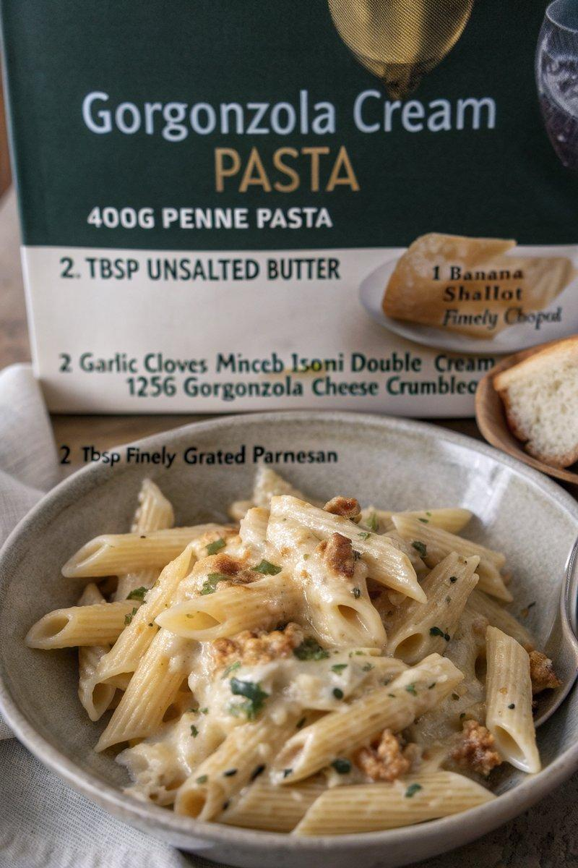

INGREDIENTS  - {'group': 'Main', 'item': '400g penne pasta'}  - {'group': 'Sauce', 'item': '2 tbsp unsalted butter'}  - {'group': 'Sauce', 'item': '1 banana shallot, finely chopped'}  - {'group': 'Sauce', 'item': '2 garlic cloves, minced'}  - {'group': 'Sauce', 'item': '150ml double cream'}  - {'group': 'Sauce', 'item': '125g Gorgonzola cheese, crumbled'}  - {'group': 'Sauce', 'item': '2 tbsp finely grated Parmesan'}  - {'group': 'Seasoning', 'item': '½ tsp salt'}  - {'group': 'Seasoning', 'item': '¼ tsp ground black pepper'}  - {'group': 'Garnish', 'item': '3 tbsp chopped flat-leaf parsley'}  - {'group': 'Garnish', 'item': '1 tbsp finely grated Parmesan'}  - {'group': 'Garnish', 'item': '2 tbsp chopped toasted walnuts'} | PREP  Finely chop the shallot and mince the garlic. Crumble the Gorgonzola cheese and grate the Parmesan. Chop the parsley and toast the walnuts in a dry pan until lightly browned.  COOK  Boil the penne pasta in salted water until al dente, then drain, reserving 120ml of the cooking water. In a large frying pan, melt the butter over medium heat. Sauté the shallot until softened, about 3-4 mins, then add the garlic and cook for another minute. Stir in the double cream, Gorgonzola, Parmesan, salt, and pepper, allowing the cheese to melt into a smooth sauce. Add the cooked pasta to the sauce, tossing to coat. If needed, add reserved pasta water to adjust the sauce consistency.  PLATING  Divide the pasta among serving plates. Top with additional Parmesan, a sprinkle of black pepper, fresh parsley, and toasted walnuts before serving.

NOTES:
For a creamier texture, use Gorgonzola Dolce. Adjust the sauce consistency with reserved pasta water as needed.

