CRISPY VEGETABLE PAKORAS  COOK TIME: 15 mins  SOURCE: Unknown  #vegetarian #indian #deep-fry | 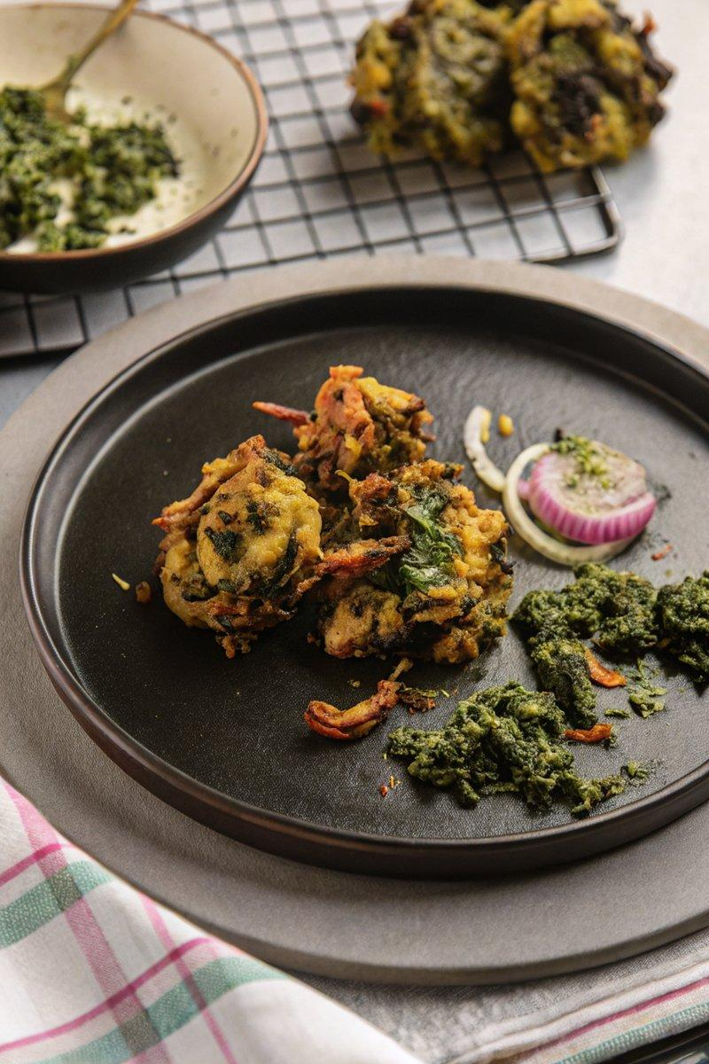

INGREDIENTS  - {'group': 'Vegetables', 'item': '1 medium russet potato, peeled and grated'}  - {'group': 'Vegetables', 'item': '1 small bunch Lacinato kale, coarsely chopped'}  - {'group': 'Vegetables', 'item': '1 medium red onion, thinly sliced'}  - {'group': 'Vegetables', 'item': '2.5 cm piece fresh ginger, minced'}  - {'group': 'Vegetables', 'item': '1 green chilli, minced'}  - {'group': 'Vegetables', 'item': '2 tbsp cilantro leaves, optional'}  - {'group': 'Batter', 'item': '90g chickpea flour'}  - {'group': 'Batter', 'item': '40g tempura batter flour'}  - {'group': 'Batter', 'item': '1 tsp garam masala'}  - {'group': 'Batter', 'item': '1 tsp ground turmeric'}  - {'group': 'Batter', 'item': '0.5 tsp ground black pepper'}  - {'group': 'Batter', 'item': '0.5 tsp fine sea salt'}  - {'group': 'Frying', 'item': '720 ml grapeseed oil'}  - {'group': 'Garnish', 'item': '1 tbsp amchur'} | PREP  Peel and grate the potato into a large mixing bowl. Add the chopped kale, sliced onion, minced ginger, minced chilli, and cilantro. In a separate bowl, whisk together chickpea flour, tempura batter flour, garam masala, turmeric, black pepper, and sea salt.  COOK  Sift the flour mixture over the vegetables and massage until well coated, about 3-4 mins. Heat grapeseed oil in a cast-iron pot to 177°C (351°F (177°C)). Test the oil with a small batter drop; it should float. Using two spoons, shape and drop batter into the oil. Fry in batches until golden brown, about 3-4 mins per batch. Drain on a wire rack.  PLATING  Sprinkle hot pakoras with amchur and serve immediately with your choice of chutney.

NOTES:
For best results, serve pakoras immediately to maintain crispiness. Pair with mint or tamarind-date chutney for added flavour.

