CHILLED WATERMELON GAZPACHO  COOK TIME: 3 mins  SOURCE: Unknown  #watermelon #Mediterranean #no-cook | 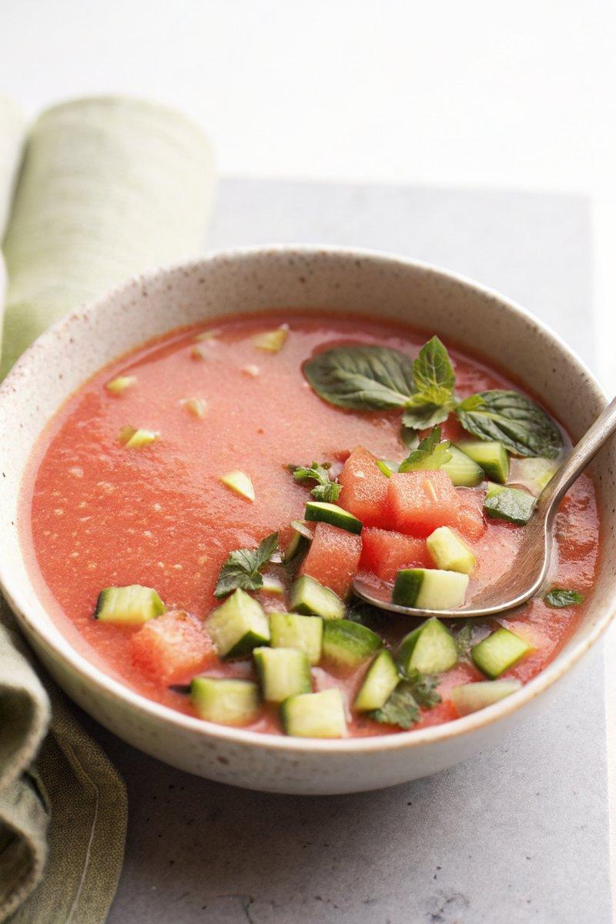

INGREDIENTS  - {'group': 'Main', 'item': '4 cups cubed watermelon (~1300g)'}  - {'group': 'Main', 'item': '1 cucumber, peeled and seeded'}  - {'group': 'Main', 'item': 'Juice and zest of 1 lime'}  - {'group': 'Main', 'item': 'Kosher salt, to taste'}  - {'group': 'Mint Oil', 'item': '30g mint leaves'}  - {'group': 'Mint Oil', 'item': '125ml olive oil'}  - {'group': 'Garnish', 'item': 'Thai basil leaves'} | PREP  Peel and seed half of the cucumber, then dice the other half for garnish and refrigerate. Char the chili over an open flame until blackened, then steam in a covered container for 3 minutes. Peel off the charred skin and remove the seeds if less heat is desired.  COOK  In a blender, combine the cubed watermelon, peeled cucumber, charred chili, lime juice, and salt. Blend until smooth. Transfer to a container, cover, and refrigerate for at least 1 hour. For the mint oil, blanch the mint leaves in simmering water for 1 second, then shock in ice water. Dry the leaves, blend with olive oil until dark green, and strain through a coffee filter.  PLATING  Pour the chilled gazpacho into bowls or glasses. Garnish with diced cucumber, lime zest, Thai basil leaves, and a drizzle of mint oil. Serve immediately.

NOTES:
This gazpacho is a refreshing starter or palate cleanser. Adjust the lime juice to taste for desired acidity.

