ROASTED TOMATO SOUP WITH GRILLED CHEESE STICKS  COOK TIME: 1 hr 20 mins  SOURCE: Unknown  #tomato #American #roast | 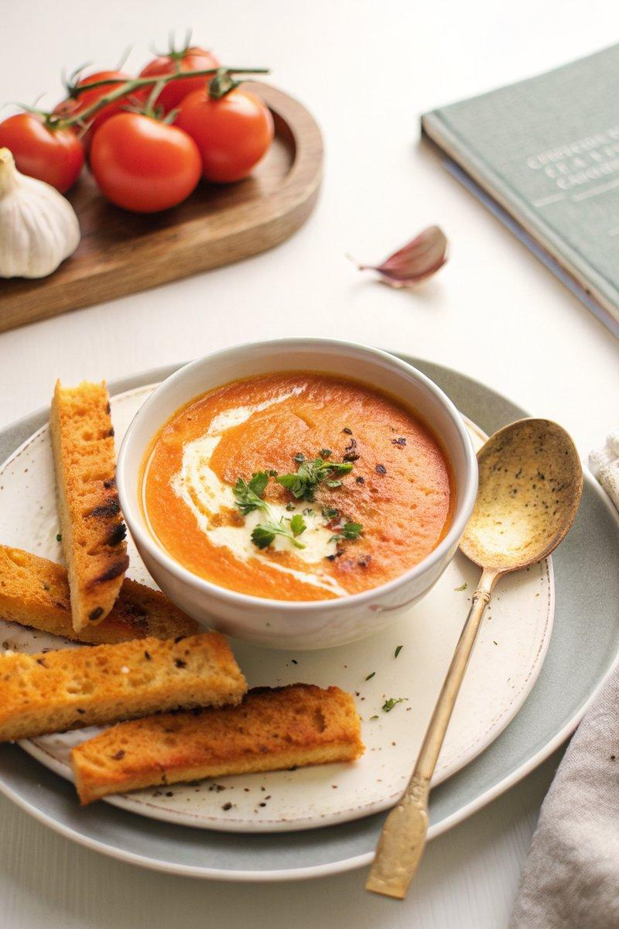

INGREDIENTS  - {'group': 'Main', 'item': '1.5 kg tomatoes, halved'}  - {'group': 'Main', 'item': '42g unsalted butter'}  - {'group': 'Main', 'item': '4 cloves garlic, grated'}  - {'group': 'Main', 'item': '2 shallots, finely chopped'}  - {'group': 'Main', 'item': '1 sprig sage'}  - {'group': 'Main', 'item': '500-750ml chicken stock'}  - {'group': 'Main', 'item': '125ml heavy whipping cream'}  - {'group': 'Seasoning', 'item': 'Kosher salt and freshly cracked black pepper'}  - {'group': 'Garnish', 'item': 'Bunch of finely chopped chives'}  - {'group': 'For Serving', 'item': 'Grilled cheese sticks'} | PREP  Preheat the oven to 200°C (400°F (200°C)). Halve the tomatoes and arrange them cut-side down on a baking sheet.  COOK  Roast the tomatoes in the oven for 30-35 minutes until charred and soft. In a large saucepan, melt the butter over medium heat. Sauté the garlic and shallots until soft. Add the roasted tomatoes, sage, and chicken stock. Bring to a boil, then reduce to a simmer and cook for 30-40 minutes until very soft. Remove the sage, stir in the heavy cream, and season with salt and pepper. Blend the mixture until mostly smooth, leaving some texture.  PLATING  Serve the soup hot in bowls, drizzled with additional heavy cream and garnished with chopped chives and freshly cracked black pepper. Accompany with grilled cheese sticks for dipping.

NOTES:
For a richer flavour, use homemade chicken stock. Adjust the cream to your desired level of creaminess.

