CLASSIC CAESAR SALAD WITH HOMEMADE CROUTONS  COOK TIME: 25 mins  SOURCE: Unknown  #salad #Mediterranean #bake | 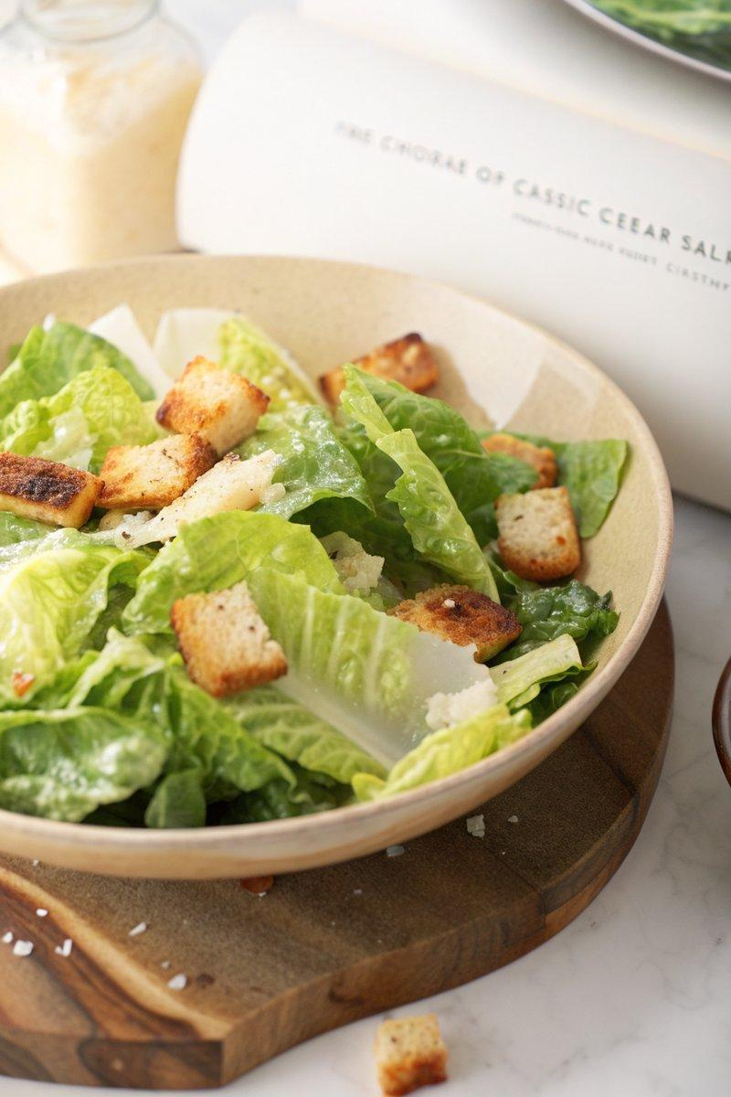

INGREDIENTS  - {'group': 'Croutons', 'item': '250g sourdough bread, cut into 2.5cm cubes'}  - {'group': 'Croutons', 'item': '60g unsalted butter, melted'}  - {'group': 'Croutons', 'item': 'Salt and freshly cracked black pepper, to taste'}  - {'group': 'Dressing', 'item': '5 cloves garlic'}  - {'group': 'Dressing', 'item': '3 anchovy fillets'}  - {'group': 'Dressing', 'item': '1 large egg yolk'}  - {'group': 'Dressing', 'item': '2 tsp Dijon mustard'}  - {'group': 'Dressing', 'item': 'Juice of 1 lemon, plus more to taste'}  - {'group': 'Dressing', 'item': '150ml neutral oil'}  - {'group': 'Dressing', 'item': '40g freshly shaved Parmigiano Reggiano cheese'}  - {'group': 'Salad', 'item': 'Romaine lettuce, lightly seasoned with salt'}  - {'group': 'Garnish', 'item': 'Freshly cracked black pepper'} | PREP  Preheat the oven to 180°C (350°F (175°C)). Cut the sourdough bread into 2.5cm (2-inch) cubes. Melt the butter and prepare the garlic by smashing the cloves with the flat side of a knife.  COOK  Toss the bread cubes with melted butter, salt, and pepper. Spread them in a single layer on a baking sheet and bake for 20 minutes, stirring occasionally, until golden and crispy. Meanwhile, on a cutting board, smash the garlic and anchovies together with salt, chopping and smearing until a paste forms. In a bowl, whisk the egg yolk, garlic-anchovy paste, mustard, and lemon juice. Slowly drizzle in the oil while whisking until emulsified. Stir in the Parmigiano Reggiano.  PLATING  In a large bowl, toss the romaine lettuce with the dressing to taste. Divide the salad among plates, topping each with croutons, additional Parmigiano Reggiano, and freshly cracked black pepper. Adjust seasoning with more lemon juice and salt if needed.

NOTES:
Store any leftover dressing in an airtight container in the refrigerator for up to one week.

