WINTER FRUIT SALAD  COOK TIME: 1 min  SOURCE:  #fresh #healthy #quick | 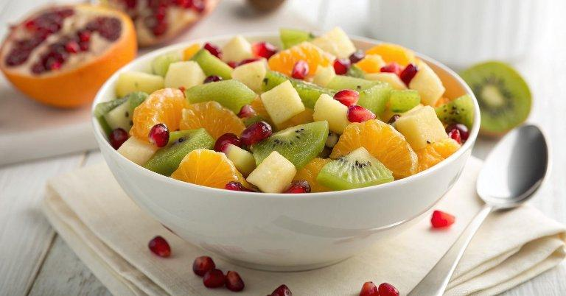

INGREDIENTS  - 3 cups (720ml) of cubed pineapple  - 1 cup (240ml) of peeled, quartered and sliced kiwis  - 2 cups (480ml) of mandarin orange or clementine segments  - 1/2 cup pomegranate arils  - 3 tbsp lemon or lime juice  - 3 tbsp honey  - 1 tbsp poppy seeds  - Optional garnish: fresh mint leaves | PREP  COOK  1. Place the pineapple, kiwi, mandarin oranges and pomegranate arils in a large bowl.  2. In a small bowl whisk together the lemon juice, honey and poppy seeds.  3. Pour the poppy seed dressing over the fruit and toss gently to coat.  4. Garnish with mint leaves if desired.  PLATING

