VEGAN STICKY BUNS  COOK TIME: 30 min  SOURCE:  #sweet #comfort-food #baked | 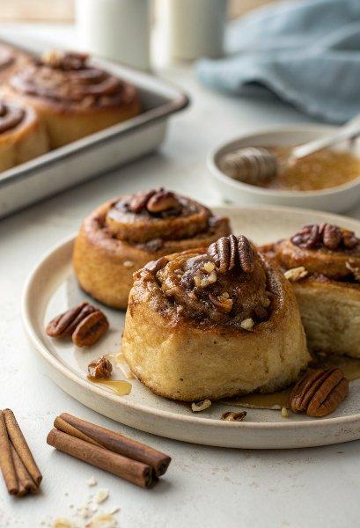

INGREDIENTS  - 2 cups (480ml) unsweetened soy milk  - 1/2 cup granulated sugar  - 2 packets (5 tsp) instant yeast  - 1/2 cup vegan butter, melted  - 1/2 tsp salt  - 4 1/2 cups all purpose flour, plus more as needed  - 2 cups (480ml) chopped pecans  - 1/2 cup vegan butter  - 3/4 cup brown sugar, lightly packed  - 1/4 cup pure maple syrup  - 4 tbsp vegan butter, softened to room temperature  - 1/2 cup brown sugar, packed  - 2 tsp ground cinnamon | PREP  COOK  1. Make the dough  2. Microwave the soy milk for about 1 minute and 30 seconds, until warm but not too hot or it will kill the yeast.  3. In a large bowl, add the warm soy milk, sugar and yeast. Stir a little bit; the yeast will get foamy.  4. To the yeast mixture, add the melted vegan butter, salt and 4 1/2 cups of flour. Stir with a large spoon until it comes together. Add additional flour, as needed. Alternatively, use a stand mixer with a dough hook and mix on low until the mixture pulls away from the sides of the bowl. It should still be soft and slightly sticky.  5. If using a stand mixer, simply mix with the dough hook until you have a smooth ball of dough. If not, turn the dough out onto a lightly floured surface, and knead for 3-4 minutes until you have a smooth ball of dough.  6. Place the dough in a lightly oiled bowl, cover with a towel and let it rise in a warm place for 20 minutes. Here's what I do: Turn the oven to 170°F (75°C). Once heated, turn it off, place the covered bowl inside the oven, and leave the oven door cracked.  7. Preheat the oven to 375 degrees F (skip this for make ahead option) and grease a 9x13-inch (23x33cm) baking dish.  8. Make the topping  9. Spread the chopped pecans in the bottom of the greased pan.  1  0. Combine the rest of the topping ingredients (vegan butter, brown sugar and maple syrup) in a small saucepan over medium heat. Stir until the butter has melted. Simmer for a few minutes, stirring frequently.  1  1. Remove from heat and pour it over the pecans in the dish.  1  2. Assemble and bake  1  3. Sprinkle a clean counter or pastry mat with flour. Punch the dough down and use a rollin pin to roll the dough into a large rectangle, about 1/2-inch (5cm) thick. Sprinkle with more flour to prevent sticking to the rolling pin.  1  4. Spread the softened vegan butter over the dough, then sprinkle with brown sugar and cinnamon.  1  5. Starting with the long edge closest to you, roll the dough into a tight log.  1  6. Using a serrated knife (or plain floss!) cut off the two ends. Slice the rest into 12 rolls.  1  7. Place the rolls on top of the pecan mixture in the baking dish. Make ahead: Cover with plastic wrap and place in the refrigerator overnight. Or follow the next step to bake immediately.  1  8. If you have refrigerated the rolls overnight, let them sit at room temperature for about an hour before baking. Bake for 30-35 minutes, until golden brown and the centers are cooked through.  1  9. Remove the baking dish from the oven and immediately invert (very carefully!) onto a serving tray or other large baking dish.  2  0. Serve these sticky sweet buns immediately and enjoy!  PLATING

