PUMPKIN HUMMUS  COOK TIME: 10 min  SOURCE:  #healthy #quick #comfort-food | 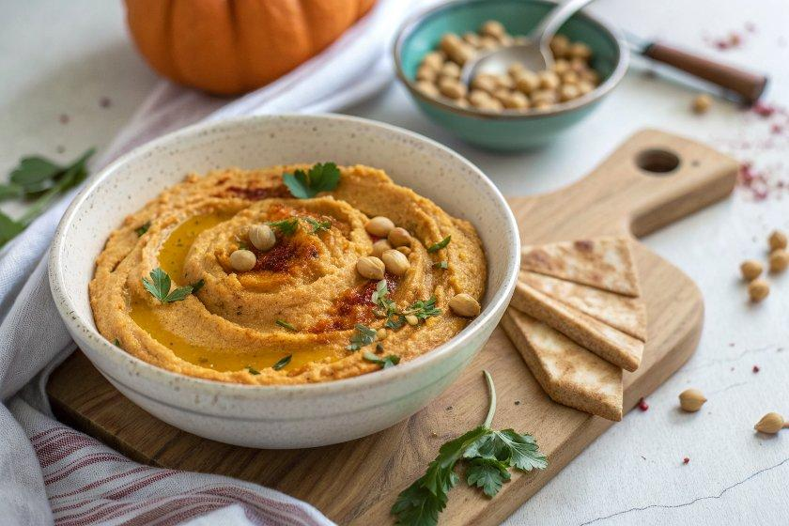

INGREDIENTS  - 15 oz can chickpeas (drained and rinsed)  - 15 oz can pumpkin puree  - 1/4 cup tahini  - 3 tbsp fresh lemon juice  - 1 clove garlic  - 1 tbsp pure maple syrup  - 1/2 tsp ground cinnamon  - 1/4 tsp ground cumin  - 1 tsp salt (or more to taste)  - few shakes ground black pepper  - 4-6 tbsp ice cold water  - For Serving: pita chips, pita bread, crackers, sliced vegetables  - pumpkin seeds (pepitas)  - pomegranate arils  - fresh herbs such as rosemary or thyme  - sprinkle of cinnamon | PREP  COOK  1. To a food processor, add the drained and rinsed chickpeas, pumpkin puree, tahini, lemon juice, garlic, maple syrup, cinnamon, cumin, salt, black pepper and 4 tablespoons of ice cold water.  2. Puree for about 5 minutes until smooth and creamy, scraping the sides as needed. If it's not quite creamy or too thick, add a few more tablespoons of ice cold water. This will help fluff it up and make it smooth.  3. Add to a bowl for serving and garnish with toppings of choice. Serve with pita chips, bread, crackers or vegetables.  PLATING

