VIETNAMESE SPRING ROLLS  COOK TIME: 15 min  SOURCE:  #quick #comfort-food #seafood | 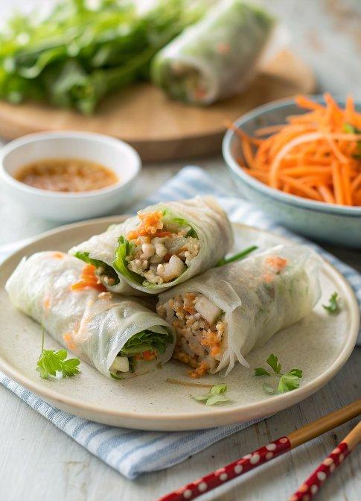

INGREDIENTS  - 1 oz mung bean noodles (or cellophane noodles or glass noodles, soaked in hot water for 30 minutes or until soft)  - 6 oz ground pork  - 2 oz shrimp (minced)  - 1 oz crab meat (coarsely chopped, optional)  - some shredded carrots  - 1 clove garlic (minced)  - 1 shallot (minced)  - 3 dashes ground black pepper  - 1 tsp fish sauce  - salt (to taste)  - 1 small egg (lightly beaten (use only half))  - Vietnamese rice paper  - oil (for deep frying) | PREP  COOK  1. Chop the soaked mung bean noodles into shorter threads. In a bowl, mix the ingredients together (excluding the Vietnamese rice paper) to create a sticky filling.  2. To roll the Vietnamese spring rolls (cha gio), place a piece of rice paper on a clean, damp kitchen towel. Dip your fingers in a bowl of warm water and run them over the entire rice paper to soften it. Place 1 heaping tablespoon of the filling onto the moist rice paper, fold the rice paper over the filling, tuck in the sides, and then roll to form a cylinder about 3-inch (8cm)es (7 cm) long.  3. Heat oil over medium heat in a wok or large frying pan. Once the oil is hot, gently add a few rolls to the oil. Fry them slowly until they turn light brown. Remove from the oil and drain the excess by placing them on paper towels.  4. Serve immediately with nuoc cham, or wrap the spring rolls in a fresh lettuce leaf with some aromatic herbs and dip them into the nuoc cham.  PLATING

