VEGETARIAN CHOW MEIN  COOK TIME: 5 min  SOURCE:  #quick #comfort-food #stir-fry | 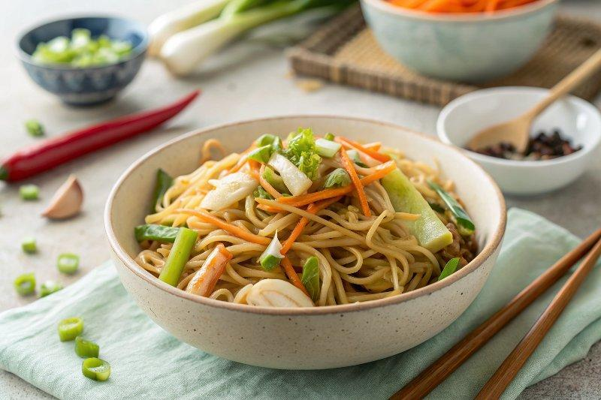

INGREDIENTS  - 6 oz / 180 g fresh chow mein noodles  - 2 tbsp oil  - 2 garlic cloves (, minced)  - 2 cups (480ml) shredded Chinese cabbage  - 1/2 cup carrot (, julienned)  - 2 scallion/shallot stems (, cut into 2"/4 cm pieces)  - 1 cup (240ml) bean sprouts  - 5 oz / 150 g firm tofu (, sliced)  - 1/2 tbsp soy sauce  - 1 tbsp Chinese cooking wine  - 1/2 tbsp hoisin sauce  - 1 1/2 tbsp soy sauce  - 1/2 tbsp chilli garlic sauce or sriracha (optional)  - 2 tsp sugar  - 1/2 tsp sesame oil  - 1/4 cup water  - White pepper | PREP  COOK  1. Prepare noodles according to packet instructions (usually soaking it in boiling water).  2. Combine tofu with marinade and set aside for 5 minutes.  3. Combine sauce ingredients in a small bowl.  4. Heat oil in wok over high heat, add garlic and stir fry for 10 seconds.  5. Add tofu and stir fry until starting to caramelise - about 1 minute. Stir fry gently so the tofu doesn't break.  6. Add the cabbage and carrot and stir fry until the cabbage starts to wilt.  7. Add the noodles, scallions/shallots, bean sprouts and sauce and stir fry until the noodles are warmed through and sauce evenly coats the noodles - about 1 minute. Don't cook it too much - the bean sprouts should still be quite crisp, not wilted.  8. Serve immediately.  9. Directions using homemade Real Chinese All Purpose Stir Fry Sauce  1  0. If you have a jar of homemade Real Chinese All Purpose Stir Fry Sauce, you do not need to make the marinade or sauce for this recipe.  1  1. Substitute the tofu marinade with 1 tbsp Stir Fry Sauce  1  2. Substitute the Sauce ingredients with 1/4 cup Stir Fry Sauce and 1/4 cup water.  PLATING

