THE BEST & EASIEST VEGAN SPINACH ARTICHOKE DIP  COOK TIME: 20 min  SOURCE:  #quick #comfort-food #party-food | 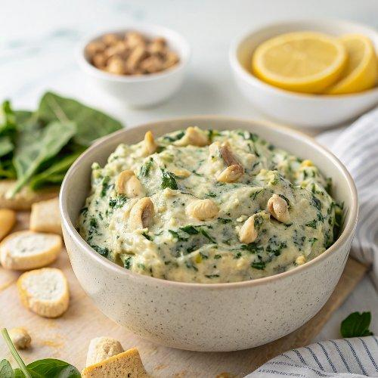

INGREDIENTS  - 1 1/2 cups raw cashews  - 4 cloves garlic  - 1 small onion, diced  - 1 1/2 cups unsweetened non-dairy milk  - 1/4 cup nutritional yeast  - 1 small lemon, juiced (2 tbsp)  - 1-1 1/2 tsp salt  - 4 cups (960ml) loosely packed fresh spinach  - (2) 14-oz cans artichokes (drained & rinsed)  - Optional: Vegan Parmesan Cheese (for serving) | PREP  COOK  1. Preheat the oven to 425°F (220°C).  2. Soak the cashews: Heat up about 3 cups (720ml) of water in a tea kettle or small pot. Pour the boiling hot water over the cashews and let them soak for 5 minutes. Drain them when ready to blend.  3. In a small pan, saute the garlic and onion for 2-3 minutes using either a tablespoon of olive oil or water, until the onion is slightly translucent. Set aside.  4. In a high powered blender such as a Vitamix, add the soaked, drained cashews, unsweetened milk, nutritional yeast, lemon juice, and 1 teaspoon salt. Blend until very smooth.  5. Now add the cooked onions/garlic, spinach and artichokes. Pulse a couple of times, but do not blend. You want to leave quite a bit of chunky texture! Taste for salt, add more to taste.  6. Transfer to an oven safe dish (I used a 9 inch pie dish) and bake for 20 minutes or so until warm, bubbly and golden brown on top.  7. Sprinkle with vegan parmesan , if desired and serve with a sliced baguette, pita chips, tortilla chips or vegetable sticks. Enjoy!  PLATING

