GYOZA BENTO  COOK TIME: 5 min  SOURCE:  #quick #bento #comfort-food | 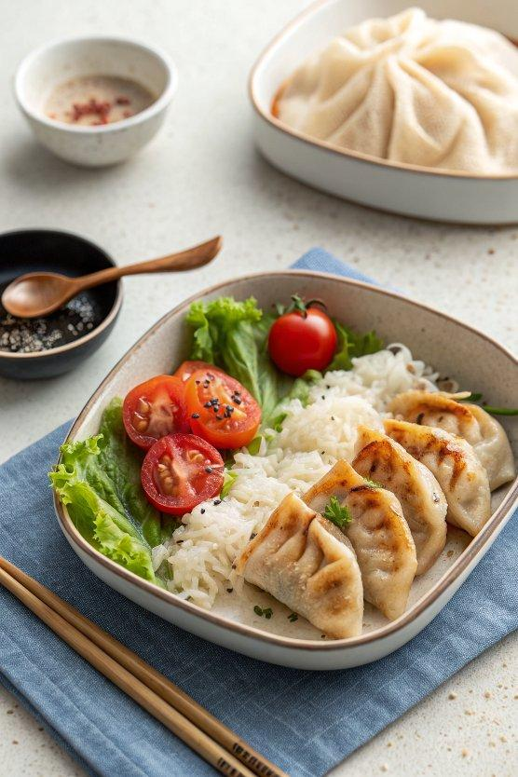

INGREDIENTS  - cooked Japanese short-grain rice (enough to fill half of your bento box)  - gyoza (pre-made; leftovers work well; see how to make homemade Gyoza or Vegetable Gyoza)  - soy sauce  - cherry tomatoes  - lettuce  - broccoli (pre-blanched; see Notes; learn how to freeze vegetables for bento ahead of time)  - Tamagoyaki (Japanese Rolled Omelette) (pre-cooked; you can use my Tamagoyaki recipe)  - chikuwa cucumber (pre-made; my Chikuwa Cucumber recipe takes just 5 minutes)  - furikake (rice seasoning) (you can make homemade Furikake) | PREP  COOK  1. Before You Start: For the steamed rice, please note that ¾ cup (150 g, 1 rice cooker cup) of uncooked Japanese short-grain rice yields 2¼ US cups (330 g) of cooked white rice. See how to cook short-grain rice with a rice cooker, pot over the stove, Instant Pot, or donabe.  2. Fill up half of the bento box with cooked Japanese short-grain rice. Let it cool so that the hot/warm rice will not warm up the other cool food.  3. Pan-fry the leftover gyoza or bake it in a toaster oven until it‘s warm.  4. Pack soy sauce in a sauce container (I bought it at a local Daiso, a Japanese dollar store).  5. Wash some cherry tomatoes and lettuce and pat dry. Place nicely in the bento box along with some broccoli.  6. Pack the cooled gyoza, Tamagoyaki (Japanese Rolled Omelette), and chikuwa cucumber.  7. Sprinkle furikake (rice seasoning) on top of the slightly cooled rice.  8. Cool down completely before closing the bento box.  PLATING

