ORANGE GINGER DRESSING  COOK TIME: 5 min  SOURCE:  #quick #healthy #zesty | 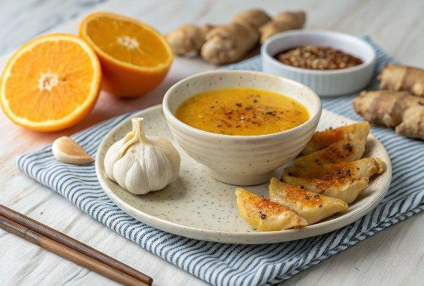

INGREDIENTS  - 1/2 Tbsp orange zest  - 2 orange  - 1 garlic clove  - 2 Tbsp tahini  - grated fresh ginger  - 1 pinch ground black pepper | PREP  COOK  1. Add all of the ingredients to a small bowl.  2. Stir, and enjoy with your favourite salad!  PLATING

