SMOKED SALMON SANDWICH WITH FETA  COOK TIME: 15 min  SOURCE:  #quick #healthy #sandwich | 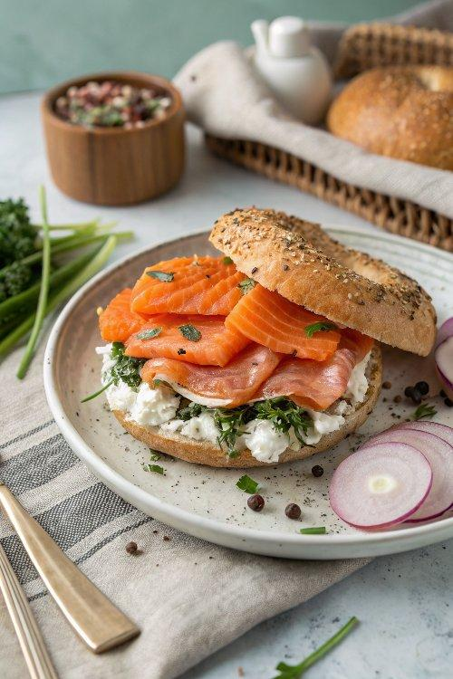

INGREDIENTS  - 1 carrot, (peeled and cut into thin, short sticks)  - 3 radishes, (cut into thin, short sticks)  - 1 green onion, (white and green parts, sliced into rounds)  - Aleppo pepper (or red pepper flakes), (to taste)  - Kosher salt, (to taste)  - 1 lime or lemon  - Extra virgin olive oil  - 1 small beet, (peeled and cut into thin, short sticks)  - 4 slices whole wheat bread, (toasted)  - 2 oz quality feta cheese  - 5 to 6 oz quality smoked salmon fillet | PREP  COOK  1. In a small bowl, combine the carrots, radish, green onion, and beets. Season lightly with kosher salt and Aleppo pepper (or red pepper flakes). Add as good squeeze of the lime and a drizzle of extra virgin olive oil and toss.  2. Combine the feta cheese with a bit of olive oil and, using the back of your fork, break up the feta and mash it so it is easy to spread.  3. Spread some feta on each of the toasted bread slices. Add the smoked salmon on top and season with a pinch of red pepper flakes and a squeeze of lime, if you like. Add the veggies on top and serve!  PLATING

