KOREAN BARLEY TEA (BORICHA)  COOK TIME: 14 min  SOURCE:  #refreshing #beverage #traditional | 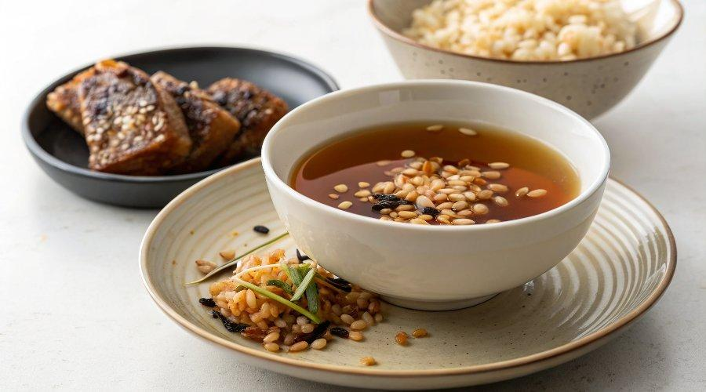

INGREDIENTS  - 2 L water  - 3 Tbsp roasted barley grains (, or more to taste) | PREP  COOK  1. A TEA BAG VERSION  2. Boil the water in a kettle (pot) until rapidly boiling. Remove the kettle from the heat then add the roasted barley tea bag. Brew it for about 10 mins. Don’t forget to squeeze out the tea bag using tongs, to get the last drop of essence. Discard the tea bag. You will noticed that the color of the water has changed to a brownish color. Cool it down. (You can submerge the kettle in cold water to make this process quicker.) Transfer the tea into a jug then refrigerate until needed.  3. LOOSE ROASTED BARLEY GRAINS VERSION  4. Boil the water in a kettle or pot until rapidly boiling. Add the roasted barley (in a tea strainer container if you have one) then boil further 5 mins on low to medium low heat. Remove the kettle from the heat and remove the roasted barley from the kettle. Cool the tea down then transfer it into a jug. Refrigerate until needed. (If you didn’t use the tea strainer container, you will have to use the strainer to sieve the grains).  PLATING

