CREAMY CAJUN GRILLED CHICKEN PASTA  COOK TIME: 25 min  SOURCE:  #quick #comfort-food #grilled | 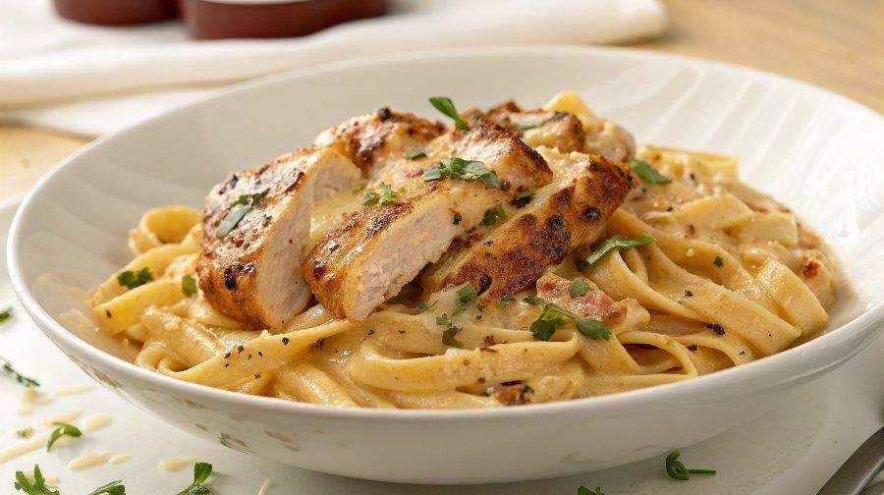

INGREDIENTS  - 1 lb boneless skinless chicken breasts ((shrimp can be substituted))  - 2 Tbsp olive oil (, divided)  - 6 tsp cajun seasoning (, divided (recipe in notes below))  - 12 oz dry linguine or fettuccine pasta  - 2 Tbsp butter  - 1 clove garlic (, minced)  - 3 Tbsp flour  - 1 1/2 cups milk  - 1/2 cup heavy cream or half and half  - 1/3 cup shredded parmesan cheese  - 1 medium red bell pepper (, sliced into thin strips then strips halved (about 1 1/2 cups))  - 1 medium yellow bell pepper (, sliced into thin strips then strips halved (about 1 1/2 cups))  - 1/2 large red onion (, sliced into thin strips)  - 2 cups (480ml) sliced button mushrooms ((about 8))  - Fresh parsley (, for garnish) | PREP  COOK  1. Heat a grill over medium-high heat. Brush chicken with 1 Tbsp of the olive oil and sprinkle with 2 tsp of the cajun seasoning (I used 2 chicken breasts and this is 1/2 tsp per side). Grill chicken until cooked through, about 8 - 10 minutes, rotating once halfway through grilling until chicken registers 165 degrees on in instant read thermometer in center of chicken. Transfer to a plate, cover with foil and let rest 5 minutes then cut into strips.  2. Boil pasta in salted water according to directions listed on package. Reserve 1/3 cup pasta water before draining.  3. In a medium saucepan melt butter over medium heat. Stir in garlic and flour and cook 1 minute, whisking constantly. While whisking slowly pour in milk and whisk vigorously to smooth lumps. Stir in 1 - 3 tsp cajun seasoning, to taste (season with additional salt as needed). Bring mixture to a boil, stirring constantly, then reduce heat to low, stir in parmesan and cream and cook until cheese has melted. Remove from heat and set aside.  4. Heat remaining 1 Tbsp olive oil in a large skillet over medium-high heat. Once hot, add red and yellow peppers and red onion and saute 2 minutes. Add 1 tsp cajun seasoning and mushrooms and saute 2 minutes longer.  5. Toss drained pasta with sauce mixture, adding reserved pasta water 1 tbsp at at time to thin sauce as desired. Toss in pepper mixture and chicken. Serve warm sprinkled with parsley and additional cajun seasoning to taste.  PLATING

