VEGAN SPINACH ARTICHOKE DIP  COOK TIME: 20 min  SOURCE:  #comfort-food #party-food #creamy | 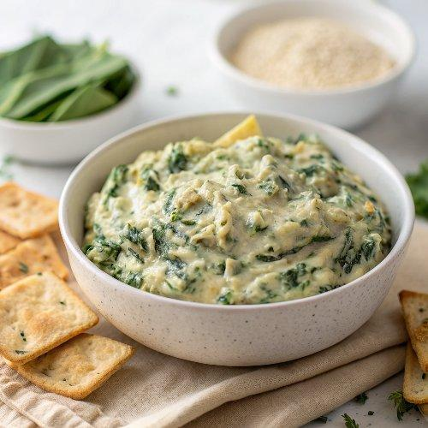

INGREDIENTS  - 3/4 cup cashews (soaked (see notes)  - 1 3/4 cups plant-based milk (see notes)  - 2 Tbsp tapioca flour (see notes)  - 3 Tbsp nutritional yeast (+ more to taste)  - 1/2 tsp paprika  - 1/4 tsp smoked paprika  - Salt and black pepper (to taste)  - 1 Tbsp oil  - 1 medium onion (diced)  - 3 cloves garlic (minced)  - 1 (14 oz) can artichoke hearts (rinsed, drained, and roughly chopped)  - 5.3 oz spinach (fresh, roughly chopped)  - Serve with bread of choice (e.g. baguette), tortilla chips, crackers, raw veggies...  - Garnish with fresh herbs and red pepper flakes (optional) | PREP  COOK  1. You can watch the video for visual instructions.First, soak the cashews in boiling water for 10-15 minutes or until soft. Then drain them.  2. Meanwhile, peel and finely dice the onion and mince the garlic. Also, chop the spinach and drain, rinse, and roughly chop the artichoke hearts.  3. While the cashews are still soaking, heat the oil in an oven-safe skillet over medium heat. Once hot, add the onion and sauté for 3-4 minutes before adding the garlic to sauté for a minute. Then, set them aside.If you don’t have an oven-safe skillet, you’ll need to transfer the dip to an oven-safe dish/ baking dish later on.  4. Next, preheat the oven to 375F/190C and add all the cashew sauce ingredients (soaked cashews, milk, tapioca flour, nutritional yeast, paprika, and salt and pepper) to a high-speed blender or food processor and blend on high until super smooth.This can take a few minutes, so pause the machine to scrape down the sides as necessary. Also, note that a blender will make a smoother sauce than a food processor.  5. Add the onion, garlic, artichokes, and spinach and pulse 4-6 times just enough to mix them into the sauce.  6. Pour the mixture back into the skillet and bring it to a boil, then reduce to a simmer for 1-2 minutes, stirring often. Taste it and adjust any of the seasonings.  7. Transfer the skillet to the oven to bake for about 10-15 minutes (I did 12 minutes), until lightly brown on top and bubbling but not overly dry.  8. Optionally garnish with red pepper flakes and fresh herbs, then serve and enjoy!  PLATING

