CHICKEN POZOLE SOUP  COOK TIME: 25 min  SOURCE:  #comfort-food #quick #hearty | 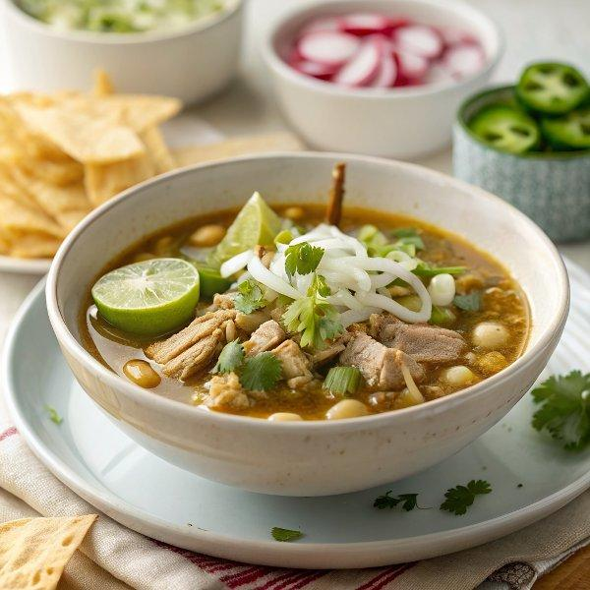

INGREDIENTS  - 1 1/2 Tbsp olive oil  - 1 medium yellow onion, (chopped (1 1/4 cups))  - 1-5 jalapeños (to taste*), (seeded and minced)  - 3 garlic cloves, (minced (1 Tbsp))  - 1 1/2 tsp chili powder, (or more to taste)  - 1 tsp ground cumin  - 6 cups (1440ml) low-sodium chicken broth  - 1 (14.5 oz) can petite diced tomatoes  - Salt and freshly ground black pepper, (to taste)  - 2 1/2 cups shredded cooked rotisserie chicken ((or left over chicken))  - 1 (29 oz) can Mexican Style hominy, (drained and rinsed)  - 1/4 cup chopped cilantro  - 1 Tbsp fresh lime juice  - 1/2 small cabbage, (chopped (cut into pieces about 3/4-inch))  - 3/4 cup shredded monterey jack or cheddar cheese  - 6 Tbsp sour cream  - 1 avocado, (diced)  - 4 oz tortilla chips | PREP  COOK  1. Heat olive oil in a large pot over medium-high heat. Add onion and saute 5 minutes then add jalapeños, garlic, chili powder, and cumin and saute 1 minute longer.  2. Pour in chicken broth, tomatoes and season with salt and pepper to taste.  3. Bring mixture to a boil then reduce to medium-low, cover and simmer until onions are soft, about 10 minutes.  4. Stir in chicken and hominy and heat through, about 1 - 2 minutes. Stir in cilantro and lime juice.  5. To serve: place a handful of chopped cabbage in serving bowl laddle soup over cabbage, top with grated cheese, diced avocados, sour cream and serve warm with tortilla chips.  PLATING

