CHICKEN STROGANOFF  COOK TIME: 30 min  SOURCE:  #comfort-food #quick #chicken | 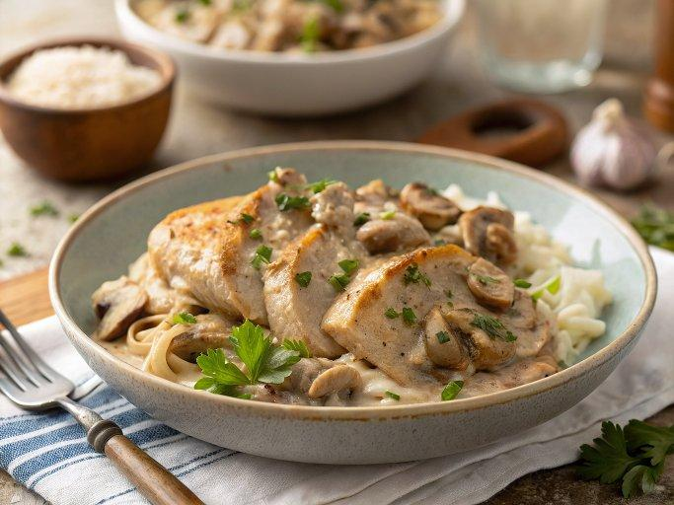

INGREDIENTS  - 2 large chicken breasts (cut in half horizontally to make 4 fillets)  - 1/2 tsp garlic powder  - 1/2 tsp paprika  - 1/2 tsp onion powder  - 1/2 tsp salt  - 1/4 tsp cracked pepper  - 3 tbsp flour  - 2 tbsp butter  - 1 tbsp olive oil  - 3 tbsp butter  - 1 large onion (chopped)  - 3 cloves garlic (crushed or minced)  - 1 lb brown mushrooms (sliced)  - 2 tsp dijon mustard  - 1 tsp paprika  - 1/2 cup dry white wine (substitute with chicken stock/broth)  - 1 tbsp flour  - 2 cups (480ml) low sodium chicken stock (broth)  - 1 tbsp Worcestershire sauce  - 1 pinch salt (to taste)  - 1 pinch pepper (to taste)  - 1/2 cup sour cream  - 1 tbsp fresh parsley (or chives, chopped to serve) | PREP  COOK  1. Season chicken all over with garlic powder, paprika, salt and pepper. Dredge each chicken breast in flour. Set aside.  2. Heat the butter and oil in a large skillet over medium heat. Sear the chicken until browned, (about 4 minutes each side). Transfer to a plate, set aside.  3. Melt the remaining butter in the pan. Sauté the onions until transparent. Add the garlic and sauté until fragrant (about 30 seconds), then add mushrooms and cook until golden, about 4 minutes. Scrape any browned bits from the bottom of the skillet (=flavour). Add in the mustard and paprika, mixing well to coat mushrooms.  4. Pour in the wine (or stock) to deglaze the pan, and let reduce for about 3 minutes while stirring occasionally to mix all of the flavours through.  5. Add flour and cook, stirring, for 1 minute, then add the broth/stock and Worcestershire sauce. Mix well to incorporate and let simmer while stirring occasionally, until the sauce begins to thicken slightly, about 2-4 minutes  6. Reduce heat to medium-low and stir in sour cream. It may 'look' split, but the sour cream will melt through the sauce while it heats through. Let simmer until sauce is smooth and creamy, about 3-4 minutes, then season with salt and pepper.  7. Return chicken breasts along with juices on the plate to the pan. Simmer for a further 2 minutes until the chicken is completely cooked through. (If sauce is too thin, simmer for a minute or 2 longer until the sauce thickens from the floured coating on the chicken.) Remove from heat.  8. Garnish with parsley or chives. Serve over noodles, pasta, mashed potatoes or rice.  PLATING

