SEARED STEAK & RED CHIMICHURRI  COOK TIME: 20 min  SOURCE:  #grilled #comfort-food #quick | 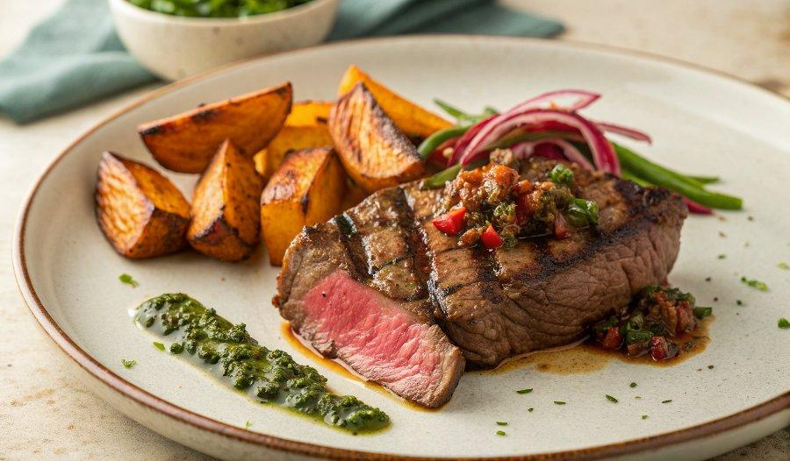

INGREDIENTS  - 1 x 260 g higher-welfare sirloin steak  - 2 cloves of garlic  - 2 sweet potatoes (250 g each)  - 1 bunch of spring onions  - 2 fresh red chillies  - 1/2 x 460 g jar of roasted red peppers  - 1/2 a bunch of flat-leaf parsley (15 g)  - extra virgin olive oil  - red wine vinegar | PREP  COOK  1. Remove and finely dice the fat from the steak. Put it into a non-stick frying pan on a medium-low heat with the unpeeled garlic cloves, turning them every minute in the fat as it gently crisps up.  2. Meanwhile, peel the sweet potatoes and chop into 4cm (2-inch) chunks. Cook in boiling salted water for 10 minutes, or until tender, then drain, smash, season and keep warm.  3. Trim the spring onions, halve and deseed the chillies, and lightly brown on both sides in the steak fat.  4. Remove 4 spring onions and the crispy fat bits to a dish, then place the rest of the spring onions and the chillies in a blender and squeeze in the soft garlic flesh. Drain and add the peppers, along with the parsley, and ½ a tablespoon each of extra virgin olive oil and red wine vinegar, then blitz until smooth, and season to perfection.  5. Turn the heat under the pan to high. Cut off the sinew, season the steak with sea salt and lots of black pepper, then cook to your liking, turning every minute. Let the steak rest for 1 minute on top of the spring onions, then slice.  6. Spoon 2 tablespoons of sauce on to each plate (save the rest for future meals), sit the steak on top with any resting juices, then serve with the sweet potato, spring onions and crispy bits.  PLATING

