COCONUT CUPCAKES  COOK TIME: 20 min  SOURCE:  #sweet #baked #comfort-food | 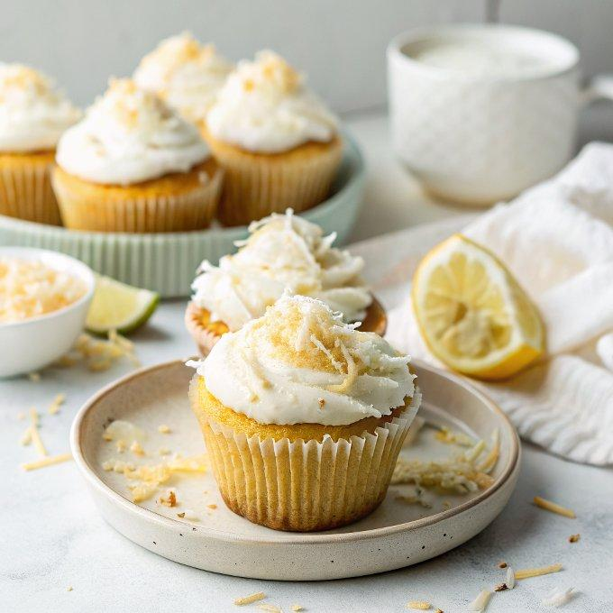

INGREDIENTS  - 1 cup (240ml) canned unsweetened coconut milk  - 2 tbsp lemon juice, (from 1 lemon)  - 2 1/2 cups all-purpose flour, (spooned into measuring cup and leveled-off)  - 1/4 cup cornstarch  - 1/2 tsp salt  - 1/2 tsp baking soda  - 1 cup (2 sticks) unsalted butter, at room temperature  - 2 cups (480ml) sugar  - 2 tsp vanilla extract  - 4 large eggs, (at room temperature)  - 1 cup (240ml) sweetened flaked coconut  - 1/2 cup (1 stick) unsalted butter, at room temperature  - 6 oz cream cheese, (at room temperature)  - 4 cups (960ml) confectioners’ sugar  - 1/2 tsp vanilla extract  - 1/4 cup canned unsweetened coconut milk  - Pinch salt  - 1 1/2 cups sweetened shredded coconut, (for topping) | PREP  COOK  1. For the Cupcakes  2. Preheat the oven to 350°F (175°C) and set an oven rack in the middle position. Line two cupcake pans with paper liners. Lightly spray the top of the pans with a nonstick cooking spray with flour, such as Baker’s Joy or Pam Baking Spray with Flour, just incase the cupcake tops stick to the pan (don’t worry if the spray gets in the liners).  3. In a small bowl, whisk together the coconut milk and lemon juice. Set aside.  4. In a medium bowl, whisk together the flour, cornstarch, salt, and baking soda. Set aside.  5. In the bowl of an electric mixer fitted with the paddle attachment (or beaters), beat the butter and granulated sugar on medium speed until light and fluffy, about 3 minutes. Beat in the vanilla, then beat in the eggs, one at a time, scraping down the sides of the bowl as necessary.  6. Turn the speed down to low and beat in one-third of the flour mixture, followed by half of the coconut milk–lemon juice mixture. Scrape down the sides of the bowl. Add another one-third of the flour mixture, followed by the remaining coconut milk–lemon juice mixture. Beat in the remaining flour mixture, then scrape down the bowl and beat again until the batter is just combined. Quickly mix in the shredded coconut; do not overmix.  7. Spoon the batter into the prepared cupcake pans, filling each cup about three-fourths full. Bake for 20 to 23 minutes, until the cupcakes are set, lightly golden, and a toothpick or cake tester inserted into the center of a cupcake comes out clean (note that one pan may finish baking before the other). Let cool in the pans for about 10 minutes, then transfer to a wire rack to cool completely.  8. For the Frosting  9. In the bowl of an electric mixer fitted with the paddle attachment (or beaters), beat the butter and cream cheese until creamy and well combined. Gradually beat in the confectioners’ sugar, and then beat in the vanilla, coconut milk, and salt.  1  0. When the cupcakes are completely cooled, use a butter knife or small offset spatula to swirl the frosting lavishly over the top. Sprinkle with the shredded coconut, pressing it gently so it adheres, and serve.  PLATING

