CREAMY COCONUT CHANA DAL  COOK TIME: 50 min  SOURCE:  #comfort-food #curry #healthy | 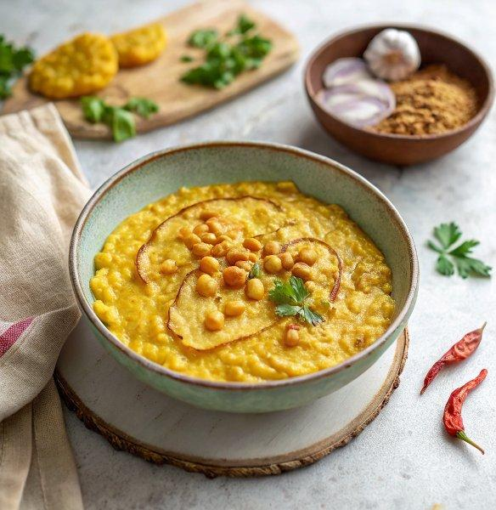

INGREDIENTS  - 1 Tbsp vegetable oil  - 2 medium onion  - 4 garlic clove  - 1 Tbsp fresh ginger  - 1 fresh red chili  - 1 Tbsp curry powder  - ground turmeric  - garam masala  - 1/2 tsp salt  - 1 1/2 cup dry chana dal  - 2 cup (480ml) water  - 1 vegetable bouillon cube  - 1 1/2 cup brown rice  - 2 cup (480ml) water  - 1 2/3 cup canned full-fat coconut milk  - 1 yellow bell pepper  - 1 red bell pepper  - 1 cup (240ml) cherry tomatoes | PREP  COOK  1. Heat the oil in a large pot over high heat. When hot, add the onion and cook until lightly golden, about 5 minutes. Add splashes of water as needed to deglaze the pot.  2. Then add the garlic, ginger, and chili and sauté for 3 more minutes.  3. Drop the heat to medium, and add the curry powder, turmeric, garam masala, and salt. Stir continuously for 30 - 60 seconds to toast the spices.  4. Add the water, drained chana dal, and bouillon. Bring to a boil, reduce to a simmer, and partially cover. Cook for 30 - 40 minutes, or until the dal is al dente*. Stir periodically.  5. Meanwhile, add the drained rice and water to a medium pot. Bring to a boil, reduce to a simmer, partially cover with a lid, and cook for 20 minutes. Then remove from the heat and leave covered.  6. Taste test the dal. When fully cooked through, add the coconut milk and bell peppers. Cook uncovered for 10 more minutes.  7. Then add the cherry tomatoes and cook for another 3 minutes. Remove from heat. Serve the dal with the rice, and garnish as desired. Enjoy!  PLATING

