CHOCOLATE PECAN PIE  COOK TIME: 55 min  SOURCE:  #sweet #comfort-food #baked | 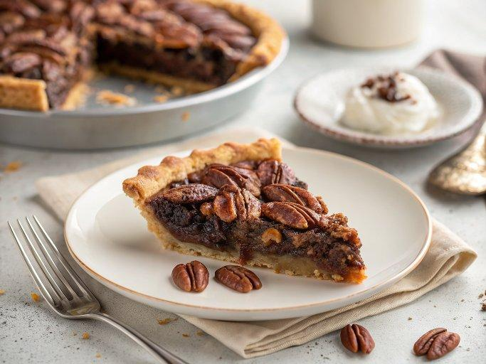

INGREDIENTS  - 1 single batch Best Ever Pie Crust,  - 1 cup (109 g) pecan halves  - 1 cup (170 g) semisweet chocolate chips  - 4 large eggs, (at room temperature, lightly beaten)  - 1/2 cup (100 g) granulated sugar  - 1/2 cup (100 g) light brown sugar  - 1/2 cup corn syrup  - 2 tbsp bourbon (optional)  - 1/2 tsp vanilla extract  - 1/4 tsp ground cinnamon  - 1/8 tsp fine sea salt | PREP  COOK  1. Preheat the oven to 375°F (190°C).  2. Remove the pie crust from the fridge. Let sit at room temperature for about 5 minutes, until slightly pliable.  3. Roll the dough out on a floured work surface. Keep turning the dough after every roll to ensure it doesn’t stick to the counter and is of even thickness. Roll out into a 13-inch (33cm) circle about 1/8-inch (20cm) thick.  4. Gently roll the dough up and around the rolling pin, then unroll and drape over a 9-inch (23cm) deep dish pie pan. Gently press into the cavity of the pie pan, being careful to avoid stretching it to fit. Use scissors or a knife to trim the excess dough, leaving a 1-inch (3cm) overhang. Fold the overhang under itself and crimp or flute.  5. Spread the pecans and chocolate chips evenly on the bottom of the pie shell.  6. In a large bowl, whisk the eggs, granulated sugar, brown sugar, corn syrup, bourbon, vanilla, cinnamon, and salt. Pour over the pecans and chocolate chips. Bake for 30 minutes, then carefully place a pie shield over the crust. Continue baking until the filling is set, about 20 to 25 minutes longer*. Remove from the oven and cool for 30 minutes before slicing and serving.  7. Cover and store at refrigerated for up to two days.  PLATING

