RADISH AND OYSTER RICE (GULBAP)  COOK TIME: 30 min  SOURCE:  #comfort-food #seafood #rice | 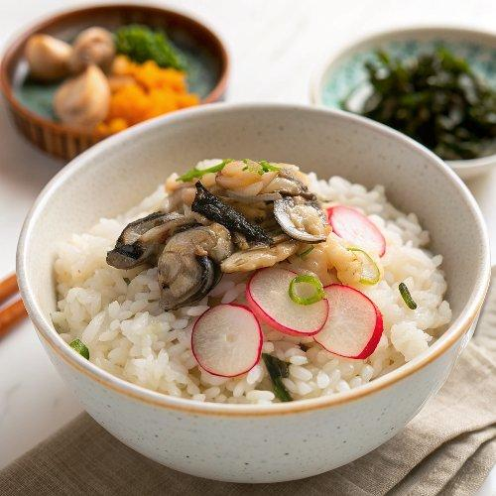

INGREDIENTS  - 1 1/3 cups short grain rice (cup is based on the rice measuring cup)  - 1 1/3 cups water  - 20 g dried kelp (kombu)  - 150 g shelled oyster (, rinsed)  - 300 g daikon radish (, peeled and julienned)  - 50 g carrot (, peeled and cubed)  - 20 g shiitake mushrooms (, washed and thinly sliced)  - 6 chestnuts (, peeled)  - 4 jujube (, pitted and thinly sliced)  - 1/4 cup soy sauce  - 1/2 tsp korean chili flakes (gochugaru)  - 1/2 tsp sugar  - 2 Tbsp garlic chives (, finely chopped)  - 1/2 red chil (, thinly sliced)  - 1 tsp sesame oil  - 1/4 tsp minced garlic | PREP  COOK  1. Soak the dried kelp in the water (1 and 1/3 cups) for about 10 mins. Remove the kelp. Keep the water for next step.  2. Rinse the rice and put it into a rice cooker pot. (If you are going to boil the rice instead of using a rice cooker, soak it in water for about 30 minutes after rinsing it.) Add the water from step 1 in the pot.  3. Add the prepared ingredients on top of the rice in the following order : radish, carrot, shiitake mushrooms, chestnuts, jujube, oysters. Set the rice cooker timer for 30 mins.  4. When it is done, serve. To eat, add the rice dressing as required onto the bowl of rice and mix them well.  PLATING

