VEGAN QUESO BLANCO  COOK TIME: 5 min  SOURCE:  #quick #comfort-food #dairy-free | 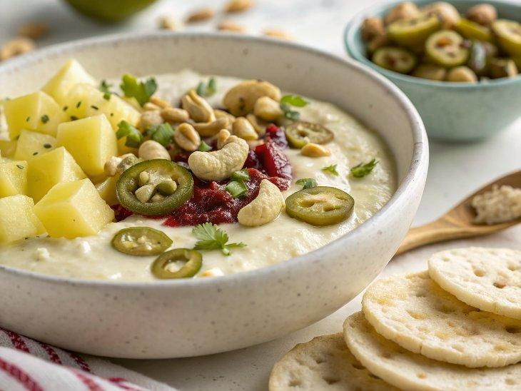

INGREDIENTS  - 1 cup (240ml) raw cashews  - 1 cup (240ml) peeled and chopped yellow or white potato (1-2 potatoes)  - 8 oz canned green chiles, mild or medium  - 2 tbsp pickled jalapeños  - 2 tbsp pickled jalapeño juice from the jar  - 2 tbsp lemon juice (about 1 lemon squeezed)  - 1 cup (240ml) water  - 1 tsp salt  - optional: finely diced tomatoes and jalapeños, for topping | PREP  COOK  1. In a small pot, add the cashews and diced potatoes, then cover with water. Bring to a boil and cook for about 10 minutes, until the potatoes are fork tender.  2. Drain the cashews and potatoes and add to a blender along with the remaining ingredients. Blend until smooth and creamy. If you have a Vitamix or similar blender, you can simply blend it until hot, without needing to warm it in a pot.  3. If you have a regular blender or prefer to warm it on the stovetop, pour the mixture into a small/medium pot and stir frequently over medium heat until hot. It will thicken as it heats up, so add more water as desired to thin the cheese sauce.  4. Top with optional diced tomatoes and jalapeños. Serve with tortilla chips, in tacos, burritos, bowls or with any other Mexican-inspired meal. Enjoy!  PLATING

