MONKEY BREAD  COOK TIME: 40 min  SOURCE:  #comfort-food #baking #sweet | 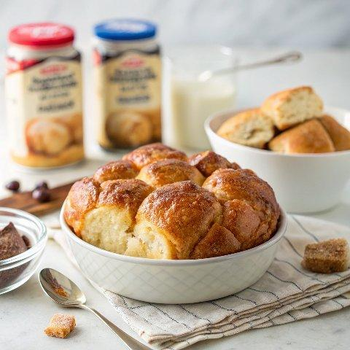

INGREDIENTS  - 3 (16.3-oz) package refrigerated buttermilk biscuit dough  - 1 cup (240ml) granulated sugar (200 g)  - 1 tbsp ground cinnamon  - 1 cup (240ml) unsalted butter (226 g)  - 3/4 cup packed light brown sugar (165 g) | PREP  COOK  1. Preheat oven to 350F.  2. Separate the biscuit dough rounds, cut each biscuit into quarters, and place the pieces in a large zip-top bag. Add the sugar and cinnamon, seal, and shake until the biscuit pieces are evenly coated (you can do this in batches if needed).  3. Lightly grease a 10-inch (25cm) bundt pan and place the coated biscuit pieces in the pan.  4. In a small saucepan, combine the butter and brown sugar. Cook over medium heat, stirring occasionally, until the mixture starts to boil and the butter is completely melted. Pour the hot sugar mixture over the biscuit pieces in the pan.  5. Bake for 40 to 45 minutes or until the top is deep golden brown. Place the pan on a wire rack and let cool for 10 minutes. After cooling, place a large serving plate on top of the pan and carefully flip the pan over to invert the bread onto the plate. Remove the pan and let the bread cool for a few more minutes before serving warm.  PLATING

