THAI CLAMS RECIPE  COOK TIME: 10 min  SOURCE:  #seafood #spicy #quick | 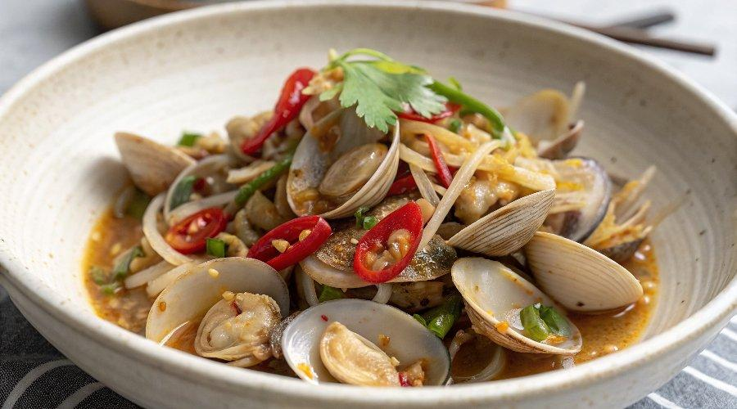

INGREDIENTS  - 1 1/2 lbs. clams  - 3 tbsp oil  - 4 cloves garlic (finely chopped)  - 2 tbsp Nam Prik Pao (roasted Thai chili paste or chili jam)  - 3 red Thai chilies (or bird&#39;s eye chilies, pounded with a mortar and pestle or sliced into small pieces)  - 1 red chili (sliced into pieces)  - 1 tbsp sweet soy sauce  - 1 tsp fish sauce  - 1 tsp sugar (or to taste)  - 1 cup (240ml) Thai basil leaves (stems removed) | PREP  COOK  1. Rinse the clams, soak them in salted water for 20-30 minutes, then scrub the shells with your hands or a brush. Rinse thoroughly under cold running water and discard any cracked or damaged clams.  2. Heat a wok or skillet over high heat and add oil. Stir-fry the garlic until aromatic, then add the Nam Prik Pao, Thai chilies and red chili. Continue stirring for 1 minute or until you smell the spicy aroma.  3. Add the clams to the wok or skillet and stir to combine with the other ingredients.  4. Add the fish sauce, sweet soy sauce, sugar, and Thai basil leaves. Stir quickly to mix everything well. Once all the clams are open, the dish is ready.  5. Dish out and serve immediately with steamed white rice.  PLATING

