AROMATIC PRAWN SMASH BURGERS  COOK TIME: 40 min  SOURCE:  #comfort-food #grilled #seafood | 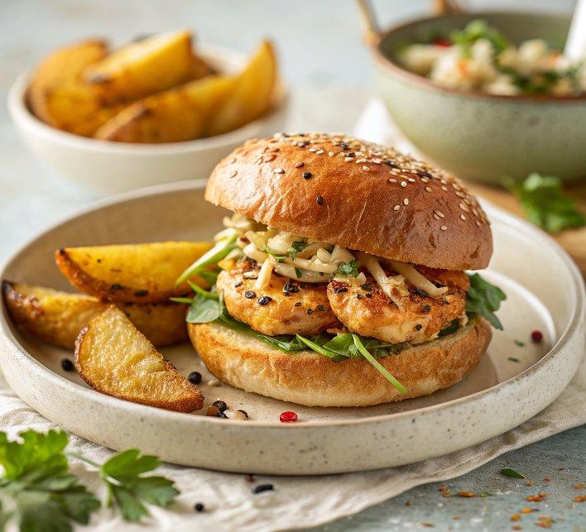

INGREDIENTS  - 900 g roasting potatoes skin on and scrubbed clean, cut into 1cm (0-inch) thick chips  - 2 tbsp olive oil  - 2 tsp coriander seeds  - 2 tsp cumin seeds  - 1 tsp black peppercorns  - 1 tsp urucum seeds (see tip, below)  - 1 tsp1 fenugreek seeds  - 1 small cinnamon stick (2 g)  - 1 1/2 tsp sumac  - 1/2 tsp garlic powder  - 1/2 tsp paprika  - 300 g peeled raw king prawns  - 60 g mango chutney  - 50 g pancetta cubes or lardons  - 10 g spice blend  - 1 tsp toasted sesame oil  - 1 tbsp neutral oil plus extra for shaping and for the spatula  - 2 brioche burger buns halved  - 20 g picked coriander  - 1 red chilli finely chopped  - 1/2 white onion halved and thinly sliced  - 1 lime half juiced, half cut into wedges  - 40 g mayo  - 40 g mango chutney | PREP  COOK  1. Heat the oven to 220C/200C fan/gas  7. Line a large, flat baking tray with baking parchment. Toss the potatoes with the oil and 1 tsp fine sea salt and spread them out into an even layer on the tray.  2. Roast for 25 mins in the middle of the oven, then stir and bake for another 5-10 mins, or until golden brown and crisp.  3. Meanwhile, make the spice blend. Add the coriander and cumin seeds, peppercorns, urucum, fenugreek seeds and cinnamon to a medium pan on a medium heat. Toast until fragrant, about 2-3 mins. Transfer to a spice grinder and blitz until coarsely ground (I prefer a little texture, rather than a fine powder). Stir in the sumac, garlic powder and paprika.  4. Tip all the ingredients for the burgers into a food processor apart from the oil, add ½ tsp fine salt and pulse to get a thick, sticky and slightly textured paste. With oily hands, divide into four portions, around 100g each.  5. Heat a large, non-stick frying pan on a medium-high heat and toast the buns until golden brown, then transfer to the oven to keep warm. Pour in the 1 tbsp oil and increase the heat to high. Oil your spatula (to ensure the patties don’t stick to it). Once the pan is very hot, add the prawn mix two mounds at a time and squash with the spatula to get thin patties, approx 10cm (4-inch) wide. Fry for 2 mins on one side, and 3 mins on the other until fully cooked, crisp and browned. Transfer to a warm oven while you fry the next two.  6. Mix the coriander, chilli and onion together with the lime juice. Spread the mayo and mango chutney over the base of the buns. Top with two patties per bun, then the coriander, chilli and onion, then finish with the top of the bun. Serve with the lime wedges and chips on the side.  PLATING

