UKRAINIAN SYRNIKI RECIPE (CHEESE PANCAKES)  COOK TIME: 8 min  SOURCE:  #comfort-food #quick #homemade | 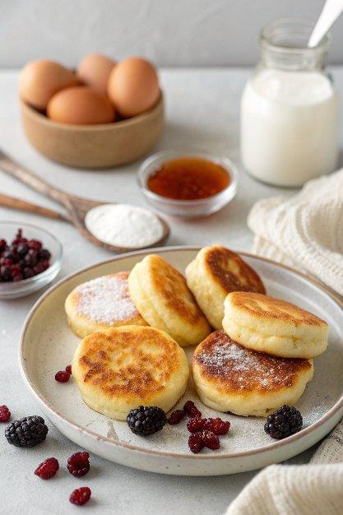

INGREDIENTS  - 15 oz about 2 cups (480ml) farmers cheese, homemade or purchase 2 packages.  - 4 large eggs  - 3/4 cups all-purpose flour + 1/2 cup for dredging  - 3 Tbsp sugar  - 1/2 tsp salt  - 1 tsp baking soda  - 1 tsp white vinegar  - 1 cup (240ml) raisins  - 2-3 Tbsp extra light olive oil for each batch  - Fresh fruit or jam (sour cream, powdered sugar; whatever you like!) | PREP  COOK  1. In a large bowl, mix together cheese, eggs, 3/4 cup flour, sugar and salt.  2. Place baking soda in a small bowl and add vinegar; give it a stir as it fizzes. Add this mixture to the cheese mix.  3. With a hand-held electric mixer, mix until uniform consistency. Stir in the raisins with a spoon. It will still have some little cheese clumps.  4. Heat a large skillet over medium heat, add 2-3 Tbsp extra light olive oil.  5. Add 1/2 cup flour to a small bowl. Place a heaping tablespoon of flat ice cream scoop of the cheese mixture into the flour. Reach into the bowl and sprinkle flour over the top of the pancake. With Well-floured hands, remove excess flour by gently transferring the pancake from one hand to another.  6. Once the skillet and oil are hot, place patties directly into the skillet as you mold them. Saute until golden brown, about 3-4 minutes each side, flipping once during cooking.  7. Transfer to a plate and serve with your favorite toppings like sour cream, fruit and powdered sugar.  PLATING

